SO301 - System Installation

Introduction
Solaris 11 was introduced in november 2011 by Oracle who purchased Sun Microsystems in early 2010. Solaris 11 is greatly inspired by Sun's Solaris 10 OS, introduced in 2005 combined with work from the OpenSolaris Community.
Solaris 10 was a major development in Operating Systems and introduced a number of innovative capabilities including:
- Fault and Service Management,
- Multiprocessor/Multicore performance scalability,
- The ZFS filesystem,
- Enhanced security with RBAC ( Role Based Access Control ),
- Virtualization with zones ( also called containers ),
- Hypervisor-based virtualisation for SPARC processors.
Solaris 11 introduces yet more capabilities as well as addressing those areas where Solaris 10 was weak ( such as package management ) compared to OSs such as Linux:
- The Image Packaging System ( IPS ),
- Simpler Automated Installation with AI, replacing jumpstart,
- Network virtualisation,
- Built-in CIFS support,
- Security enhancements,
- New ZFS features,
- CUPS
- Distribution Constructor,
- Boot environments,
- New container features,
- NIC auto-detection,
- Enhanced Multicore processor support.

Installation
Solaris 11 can be installed from one of three ISO images :
Method | Description
Text Install | CD sized ISO which can be used on both x86 and SPARC platforms to install a text only operating system.
Automated Installer | Same as above but also supports hands-free network-based minimal installations.
Live Media | DVD sized ISO which boots into a live x86 version of Solaris 11 containing the installation program.
This training module concentrates on the Text Install and Live Media methods of installation.
The minimum hardware specifications for Solaris 11 are as follows :
Hardware | SPARC | x86 (64-bit ONLY)
Processor Achitecture | Sun 4v ( T Series ) , SPARC 64 | Intel Xeon, i3, i5, i7, AMD Opteron
Minimum Memory | 1GB | 1GB
Recommended Memory | 1GB | 1GB
Minimum Disk Space | Text Install: 2.9GB, Automated Installer: 2.5GB, Live Media: 5GB | Text Install: 2.9GB, Automated Installer: 2.5GB, Live Media: 5GB
Recommended Disk Space | Text Install: 4.9GB, Automated Installer: 13GB, Live Media: 7GB | Text Install: 4,9GB, Automated Installer: 13GB, Live Media: 7GB
Oracle's Hardware Compatibility List is available at their HCL web site: http://www.oracle.com/webfolder/technetwork/hcl/index.html.

Preparing for Installation

Dual Boot Environments
If you intend to install Solaris 11 alongside Linux:
- Deactivate the Linux swap partition under Linux before proceeding further. This is necessary because the swap partition is seen by Solaris 11 as Linux Swap / Solaris and therefore Solaris 11 will try to use it as a native Solaris partition,
- Note that you must use the Solaris 11 version of the bootloader grub. This is because the Solaris 11 grub has been enhanced to be able to boot both Solaris and Linux whereas the Linux version of grub cannot boot Solaris. You must copy the Linux boot stanza from the Linux grub configuration before installing Solaris so that you can paste it into the Solaris grub configuration,
- If you need to free up disk space on a Linux installation in order to install Solaris 11, you should use the Live Media installation process since it contains the gparted program that you will need to use prior to installing Solaris 11.
If you intend to install Solaris 11 alongside Windows™:
- You should use the native Windows™ disk management tools to free up space.

Virtualisation
Solaris 11 can be installed as a virtual appliance on many hypervisor applications :
- Oracle VirtualBox,
- Oracle VM for x86,
- Oracle VM Server for SPARC,
- VMware vSphere 5.1,
- Xen,
- Citrix XenServer.
During this course you will be using the Oracle VirtualBox application to install and use Solaris 11.

LAB #1 - Installing via Text Install
Create a new virtual machine in VirtualBox with a 20GB vmdk hard disk and 2048MB of RAM.
Start the new machine and tell it to boot the Text Install ISO:
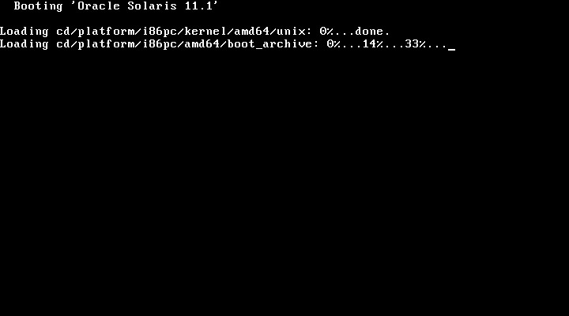
The process then starts to probe for devices:
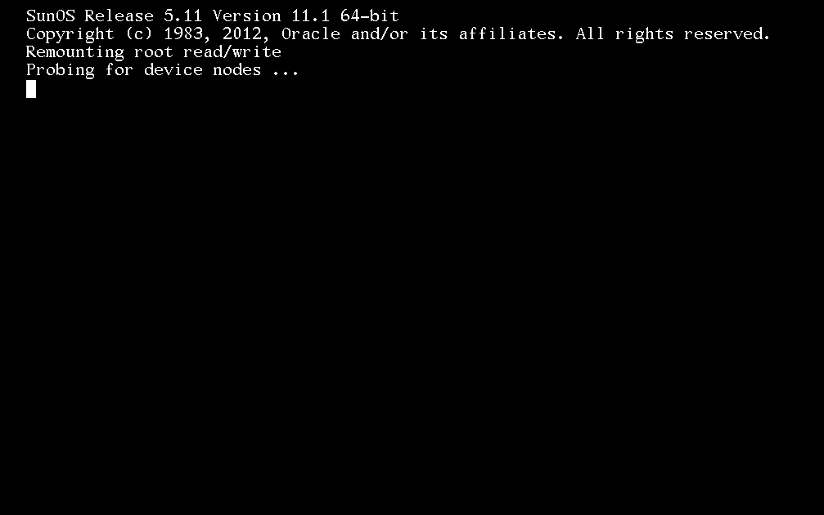
The system now prompts you to choose a keyboard layout:
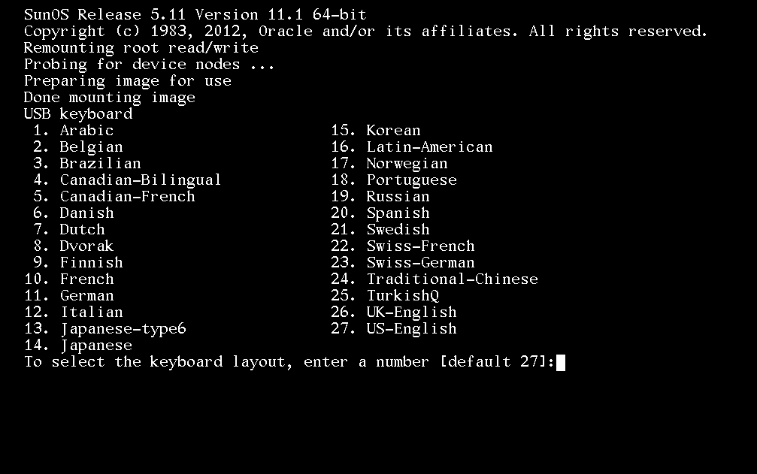
Followed by the choice of the installation language:
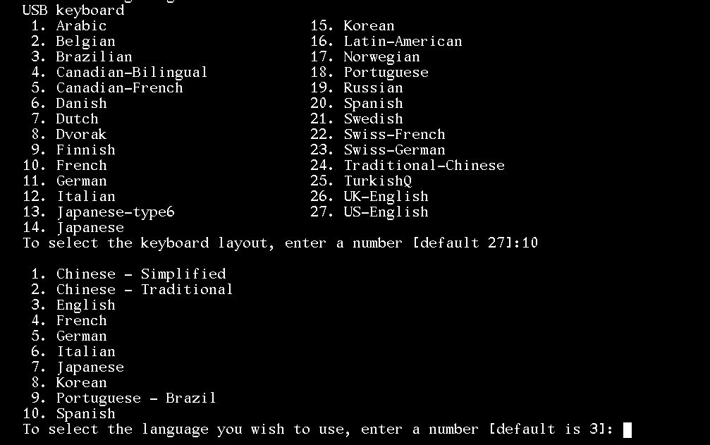
The system is now ready to be installed. Choose the default value of 1 and hit ↵ Enter:
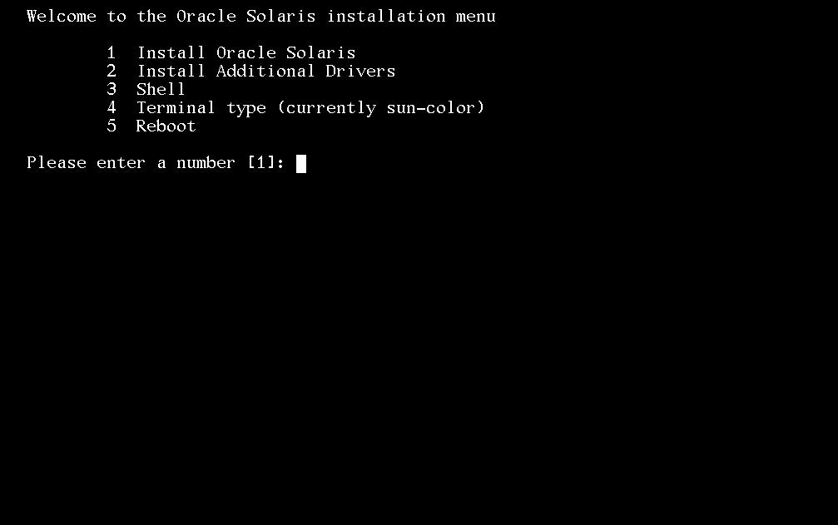
A screen showing both the installation log location and some instructions appears:
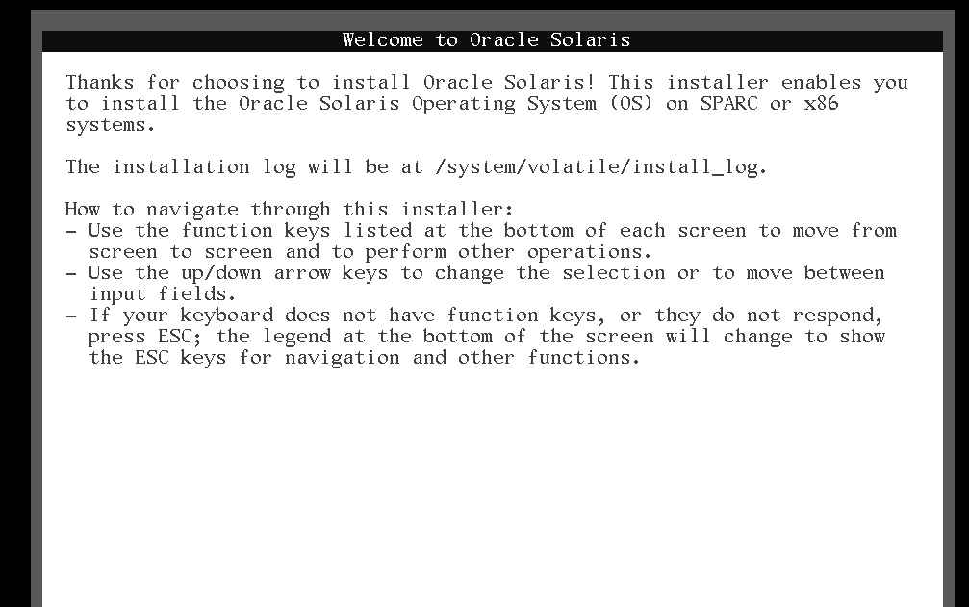
Move to the following screen using the F2 key. If the function key does not work or is absent, hit Esc then Esc 2 at the same time. This screen asks you to choose either Local Disks or iSCSI LUN discovery. For the purpose of this installation, you should choose Local Disks:
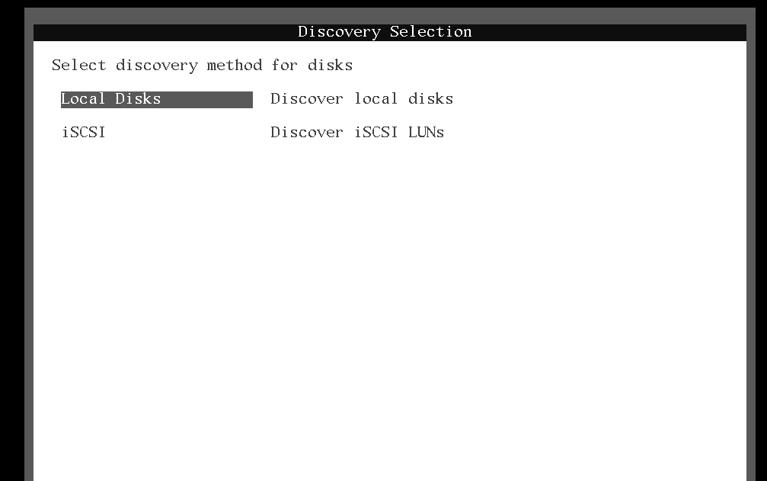
Move to the next screen using the F2 key or the Esc 2 keys as shown at the bottom of the current screen:
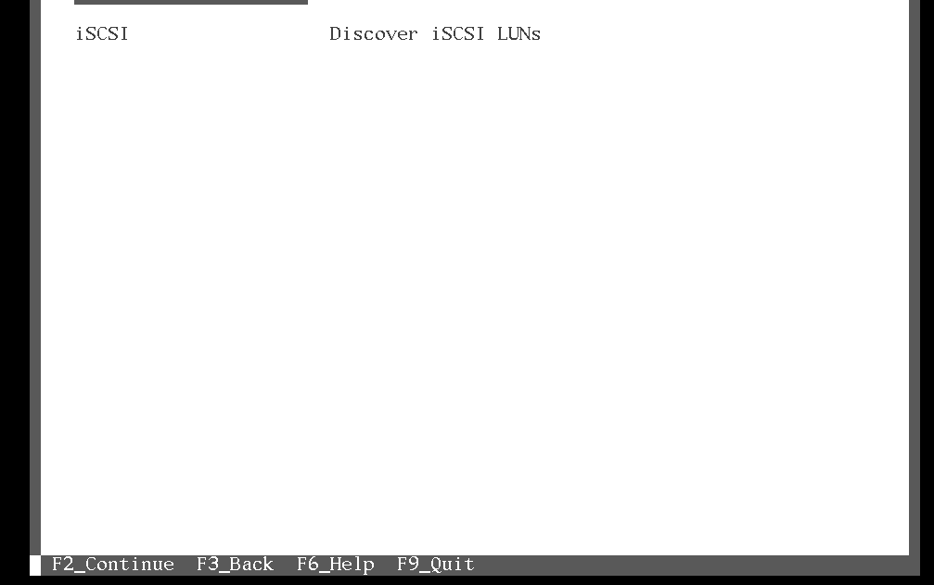
The system should now have discovered the local disk to install to. Since in the case of this example, we are installing to a new media, no GPT labeled disk has been found. The installation program suggests a partition table. Note the name of the device is of the following format c?t?d?:
Letter | Description | Starting Value
c | Disk controller device number | 0
t | Controller's target number | 0
d | Disk number on the controller | 0
Make sure the disk is highlighted and then hit ↵ Enter:
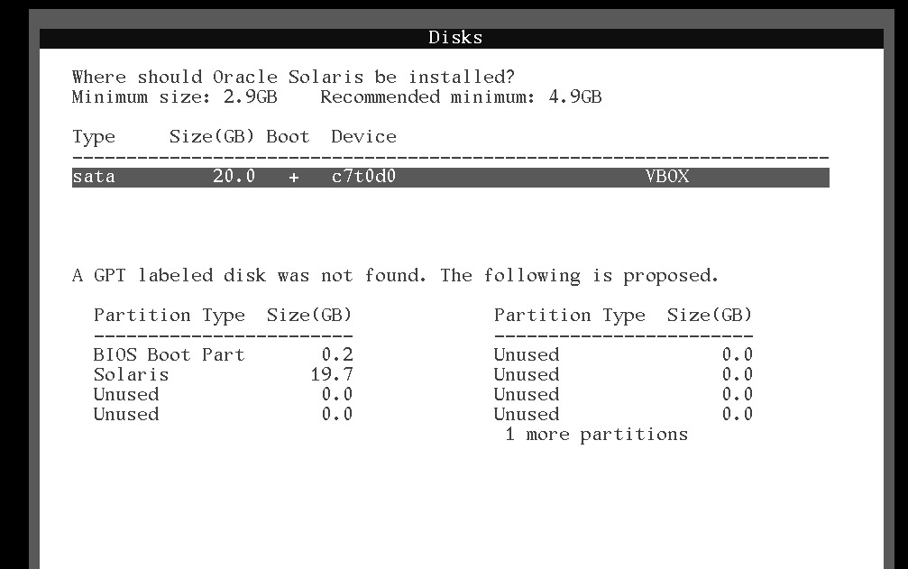
At this stage you can choose to either install to the entire disk ( the default choice ) or install to a partition in the case of a multiple boot environment. Highlight the Use the entire disk option and hit the F2 key or the the Esc 2 keys:
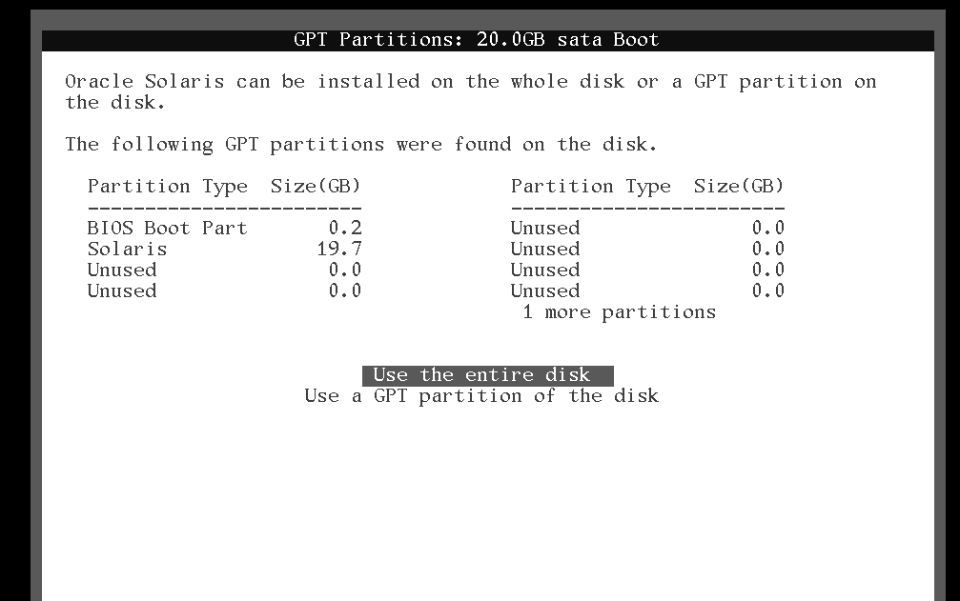
You now need to specify a name for the system. Use the same one as in the example - fenestros.solaris.loc:
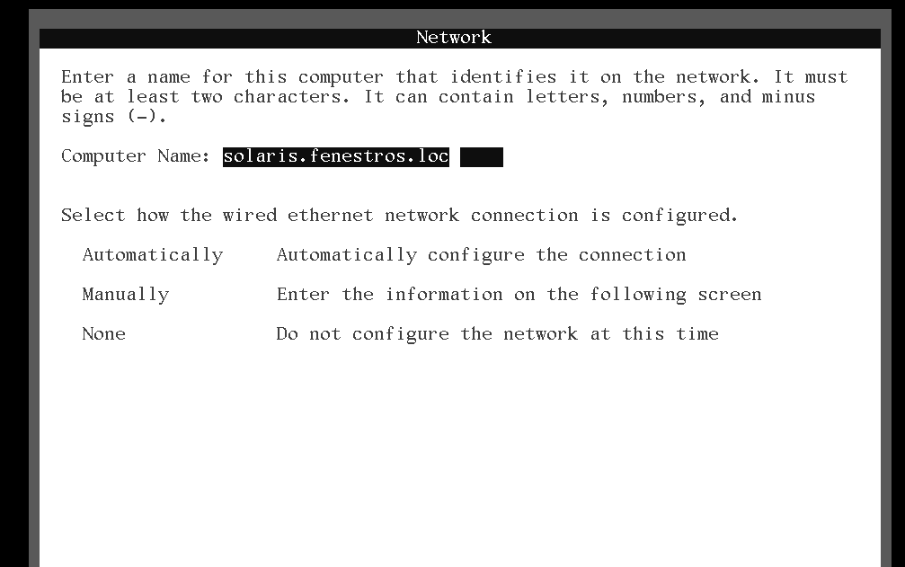
Highlight the Automatically option in order to automatically configure the network connection via DHCP and hit the F2 key or the the Esc 2 keys:
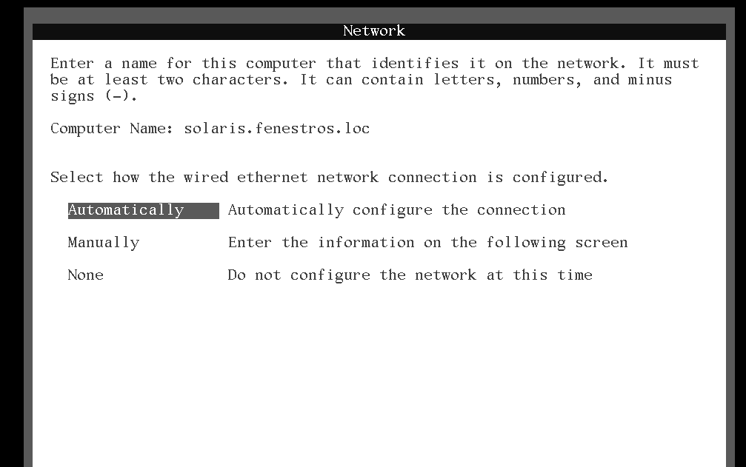
Select the region that contains your time zone and hit the F2 key or the the Esc 2 keys:
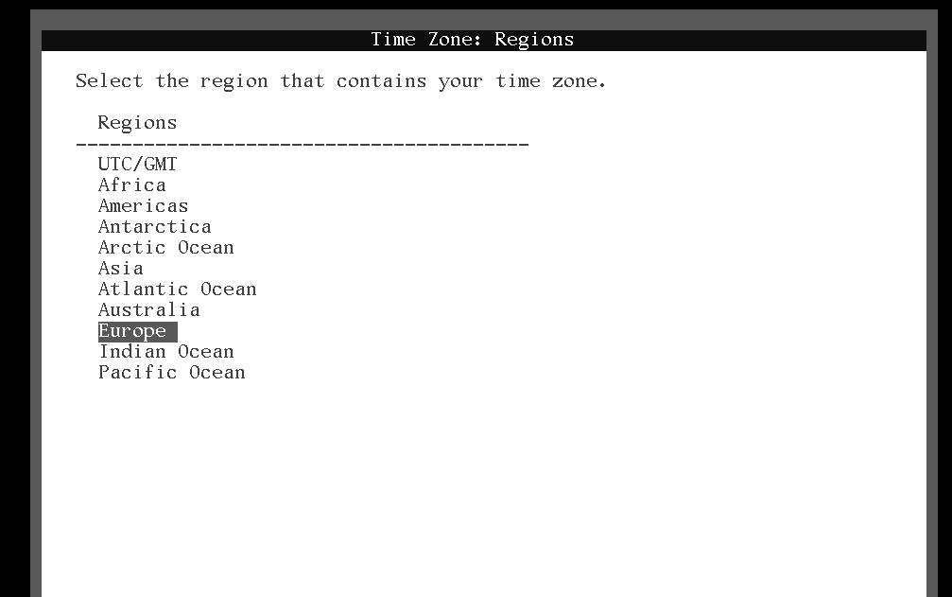
Select the location that contains your time zone and hit the F2 key or the the Esc 2 keys:
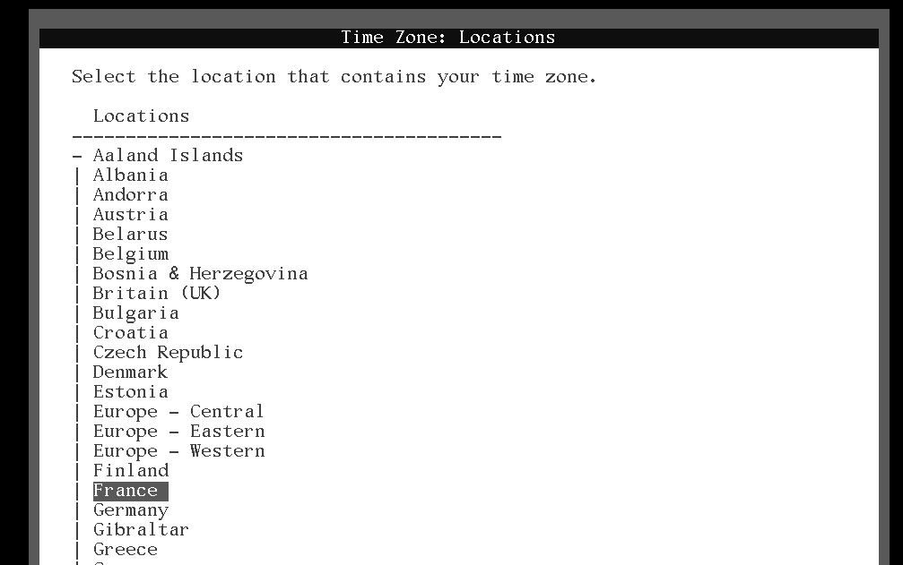
Select your time zone and hit the F2 key or the the Esc 2 keys:
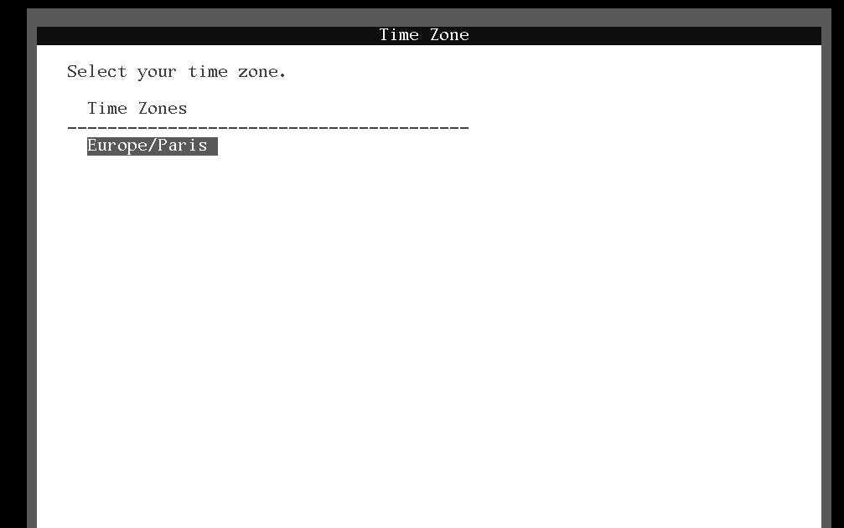
Check the date and time and correct if necessary then hit the F2 key or the the Esc 2 keys:
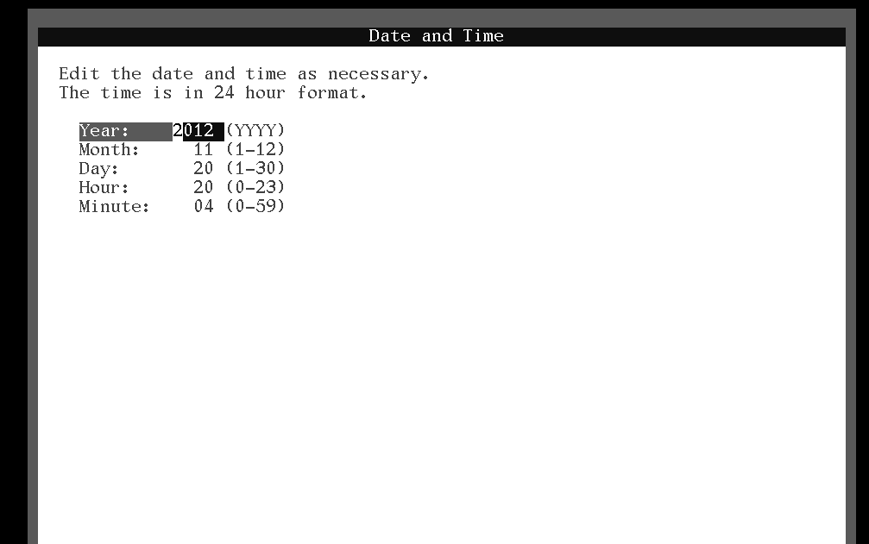
You now need to specify the root ( Administrator ) password and the name and password of the first user on the system. Several points need to be considered here :
- The default password-hashing program in Solaris 11 is SHA-256. This means that the passwords are no longer limited to 8 characters as in the case of Solaris 10,
- The default password security policy requires that passwords contain at least one digit and one special character,
- Under Solaris 11, the root user is a role indicating that you cannot log in directly with the root account,
- The first user created on the system is assigned the root role so that he/she can become root using the su command.
For the purposes of this training course, specify fenestr0$ as the password for root and trainee/fenestr0$ as the username and password of the user to be created.
When installing a machine for production purposes, do not use the same password for the root and user account!
When you have finished, hit the F2 key or the the Esc 2 keys:
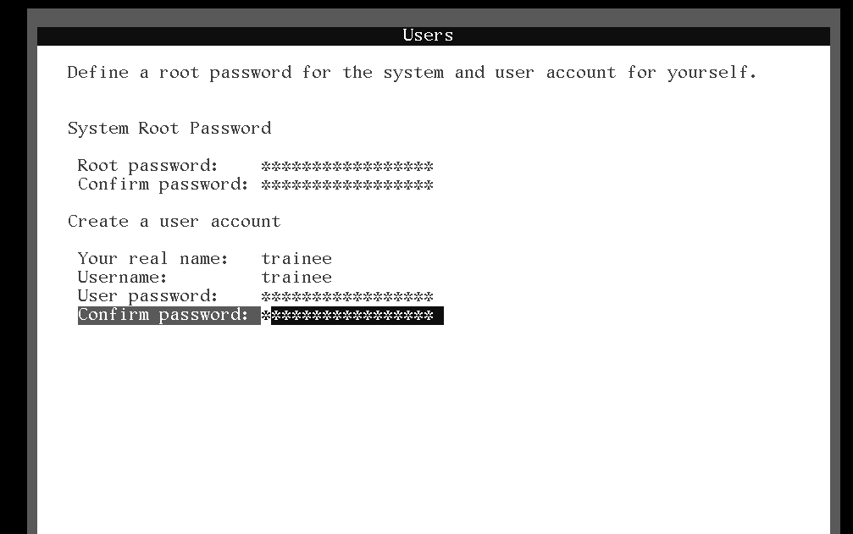
At this stage you should enter the email address and password of your Oracle Support Account.
Oracle's licensing policy for Solaris 11 does not permit you to put a Solaris 11 system into production without an Oracle Support Account.
Since the licensing policy does allow you to evaluate Solaris 11 for an indefinite period, enter your email address but leave the password field empty. When finished hit the F2 key or the the Esc 2 keys:
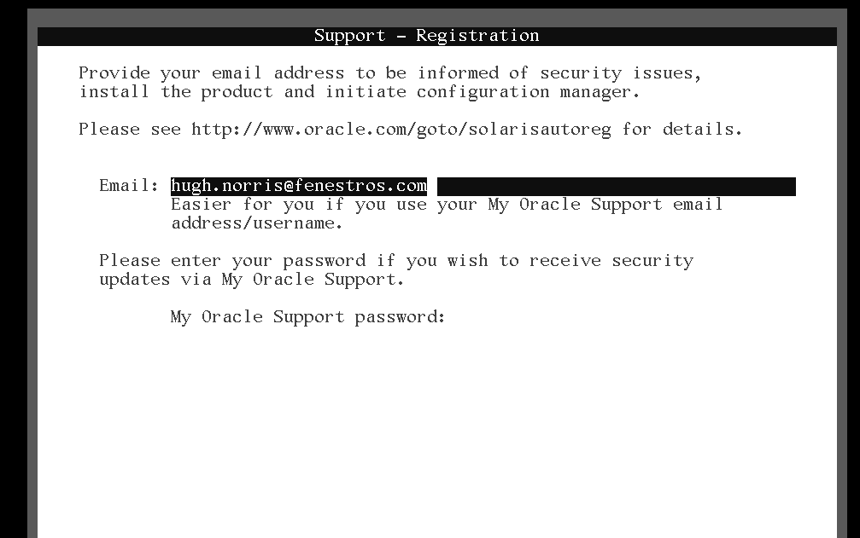
If your network uses a proxy, enter the details here. If not choose the No proxy option and hit the F2 key or the the Esc 2 keys:
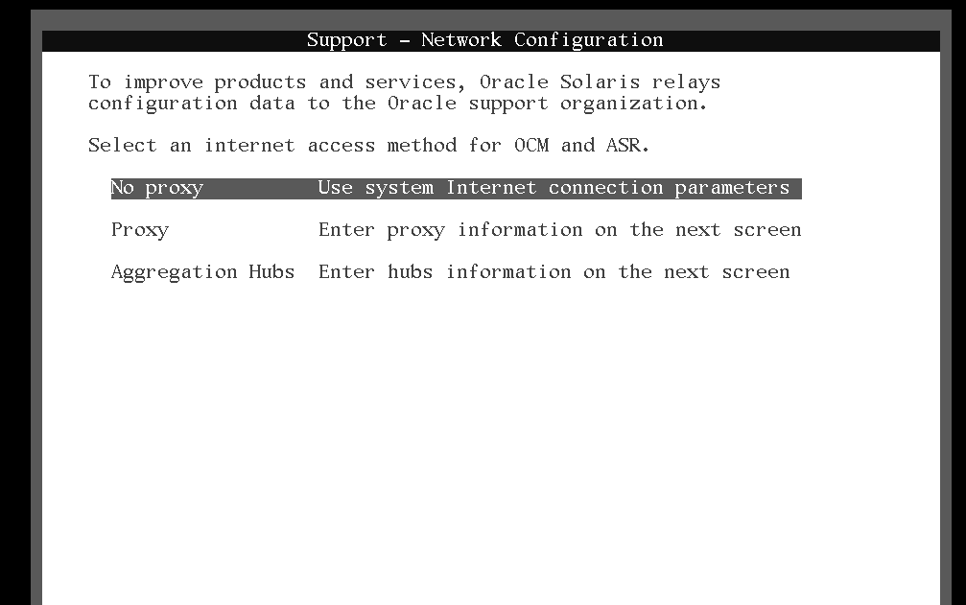
Review the Installation Summary and modify it if necessary. If not, hit the F2 key or the the Esc 2 keys:
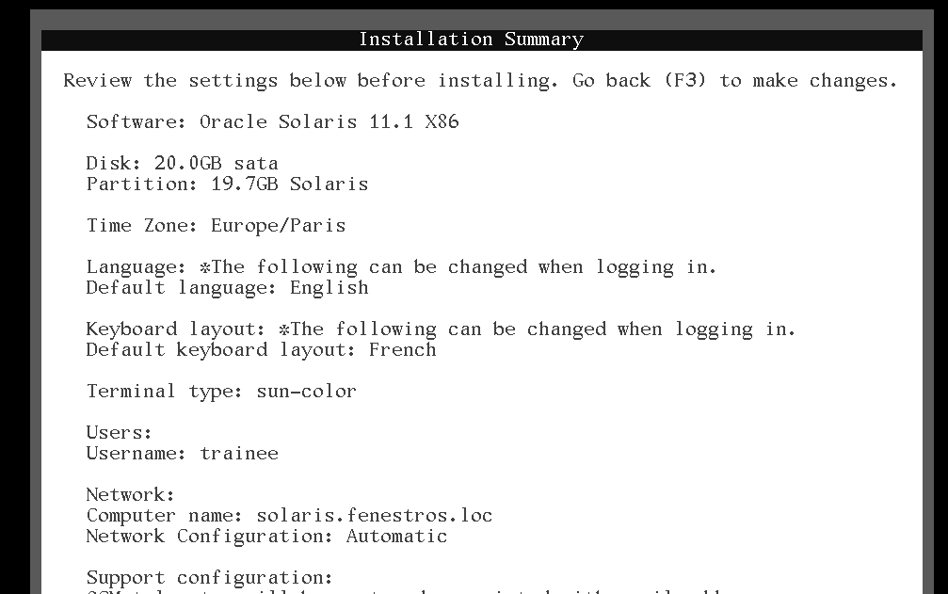
The system will now be installed:
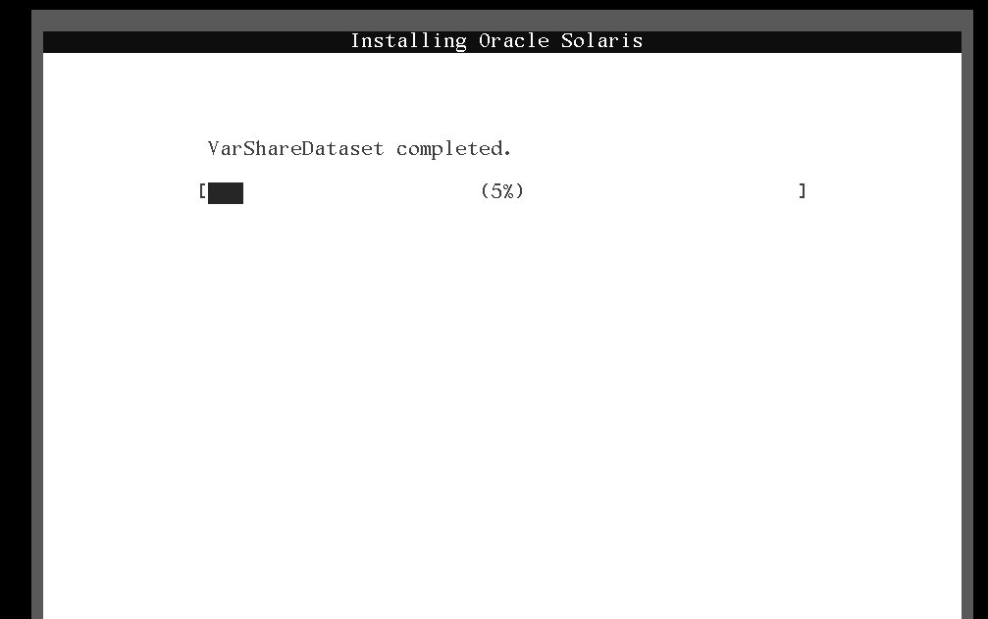
At the end on the installation, the screen shows you where you will find the installation log after rebooting. Hit the F8 key to reboot:
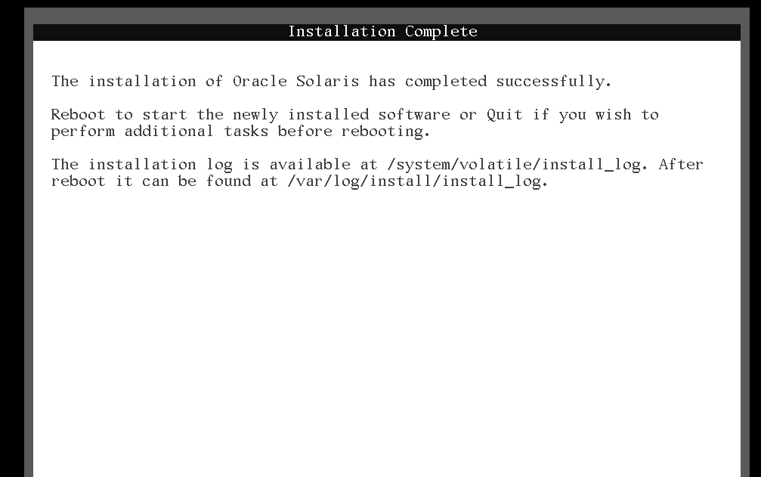
Your newly installed Solaris 11 system will reboot:
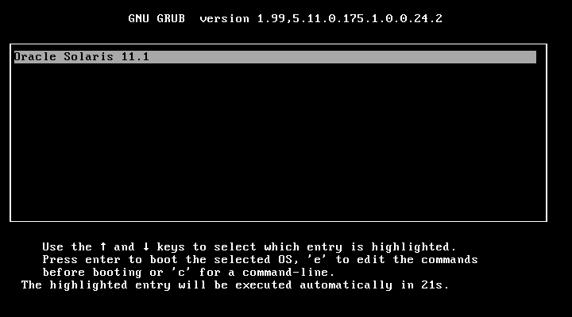
Once booted, log into the system from the command line using the trainee/fenestr0$ account. In order to install the gnome desktop environement, use the following command :
trainee@solaris:~$ sudo pkg install slim_install
Password: fenestr0$
The password will not be shown. It is so in the example above so that you do not forget what it is!
Once all the packages are installed, use the following command to start the graphical log in service at boot:
trainee@solaris:~$ sudo svcadm enable gdm
Re-boot the machine and log in graphically :
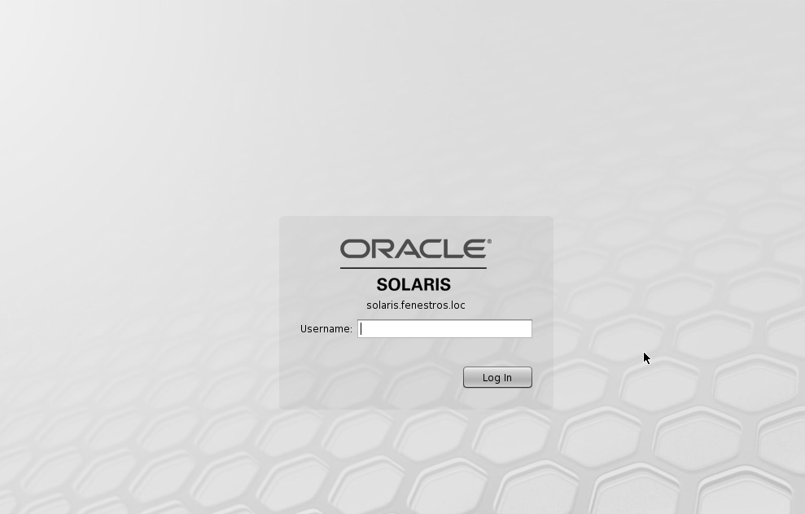
Once logged back in, you need to install the VirtualBox Guest Additions. To do so click on the VirtualBox Devices menu. Select the Install Guest Additions menu item. VirtualBox will mount the VirtualBox Guest Additions ISO and an icon will appear on your desktop:
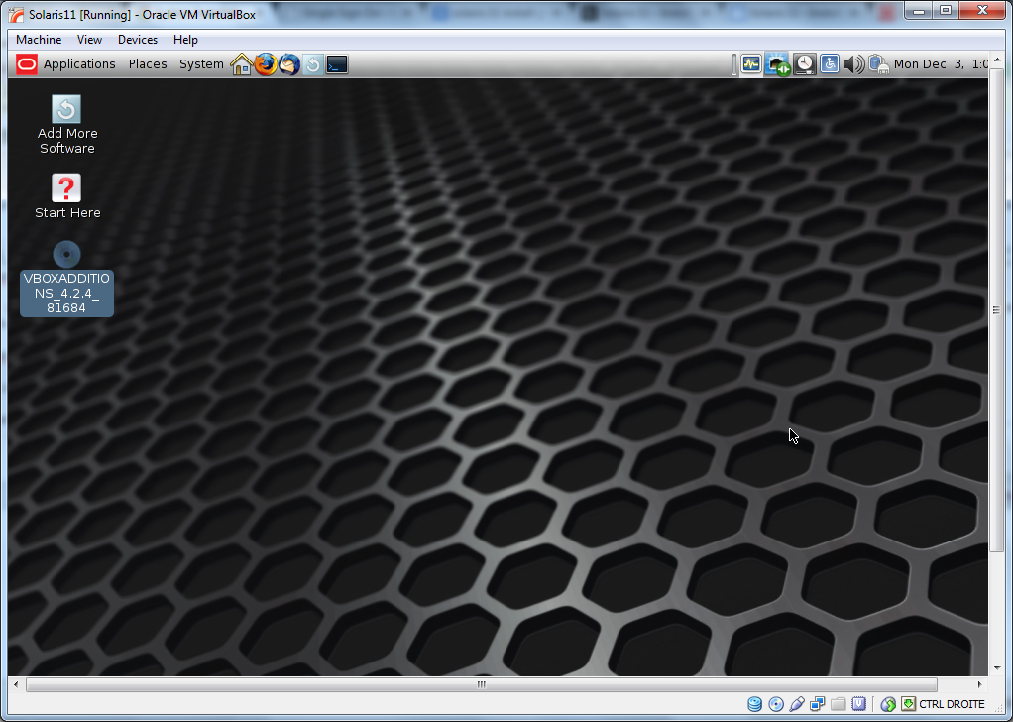
Double click on the icon to open the window containing it's contents:
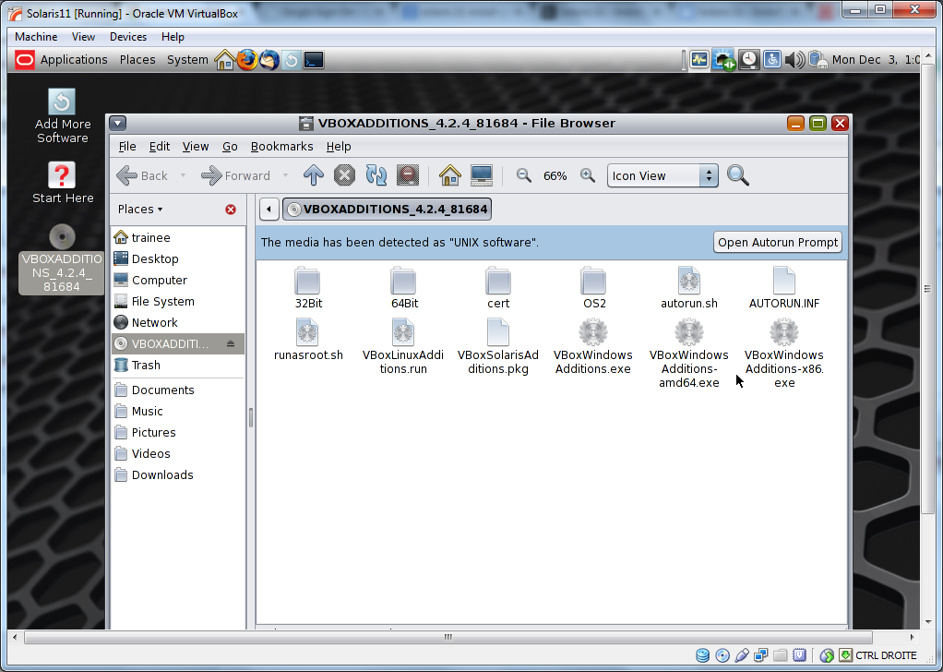
Highlight the VBoxSolarisAdditions.pkg package and click on the Open Autorun Prompt button:
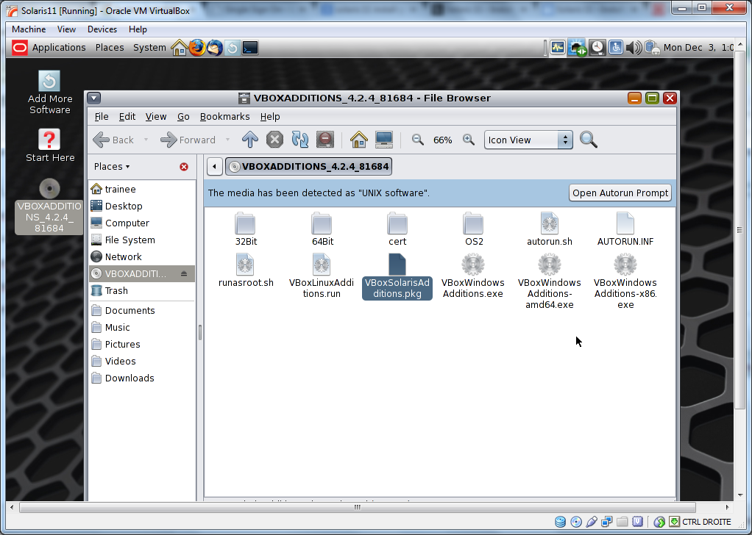
In the pop-up box, click on the Run button:
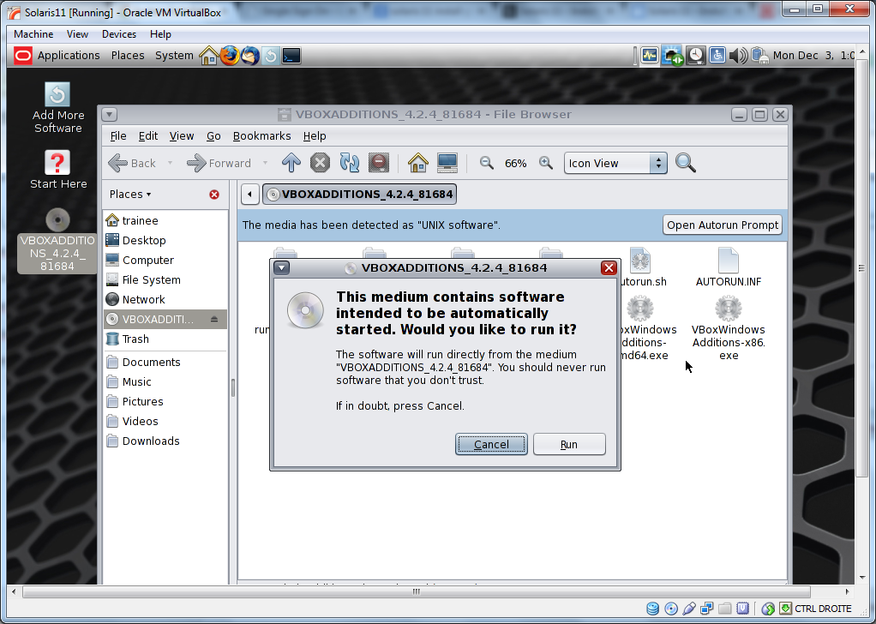
In the terminal that pops up asking for a password, type fenestr0$:
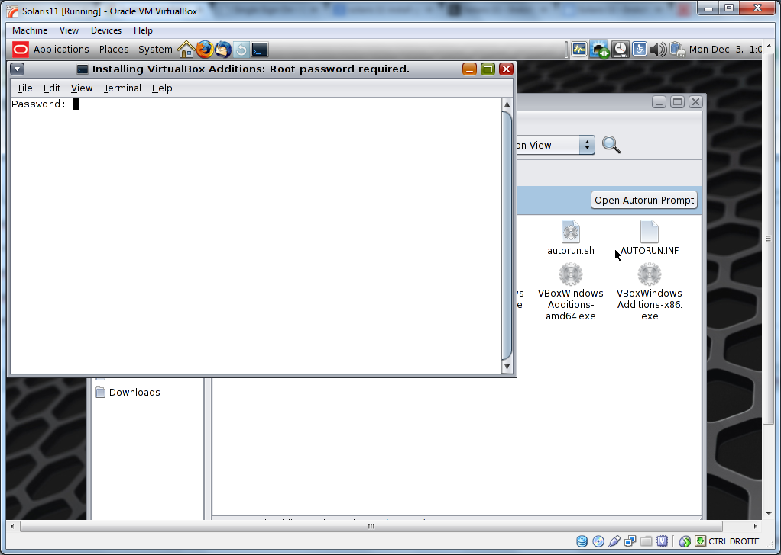
Wait until the installation has completed and then hit ↵ Enter to close the terminal:
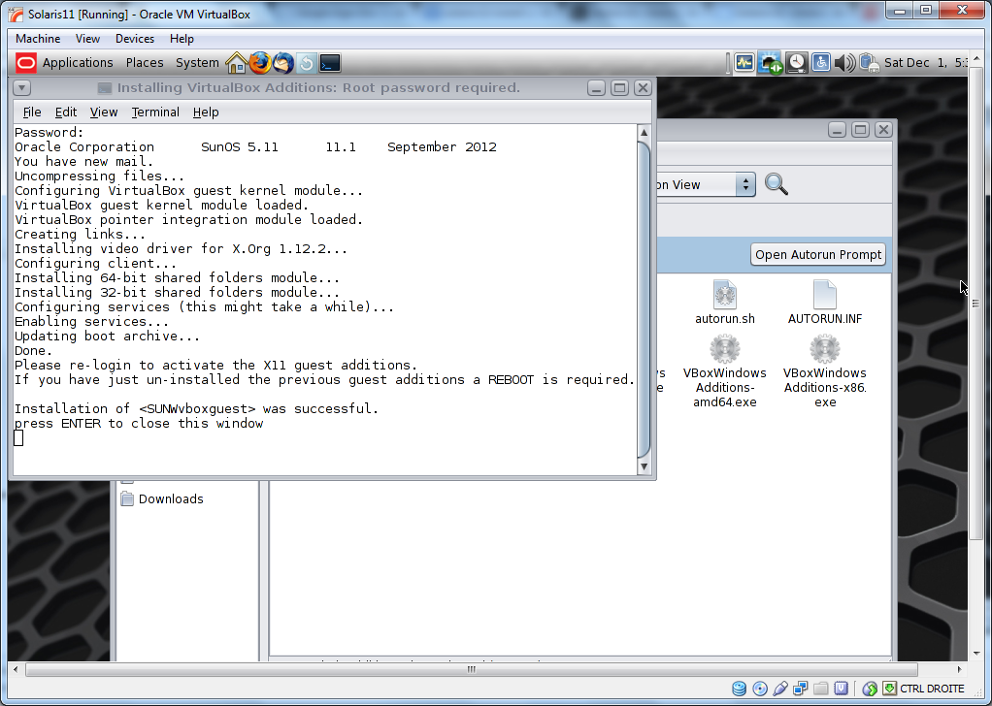
Eject the ISO image and reboot the system.

LAB #2 - Live Install in VirtualBox
Create a new virtual machine in VirtualBox with a 20GB vmdk hard disk and 2048MB of RAM.
Start the new machine and tell it to boot the Live Media ISO:
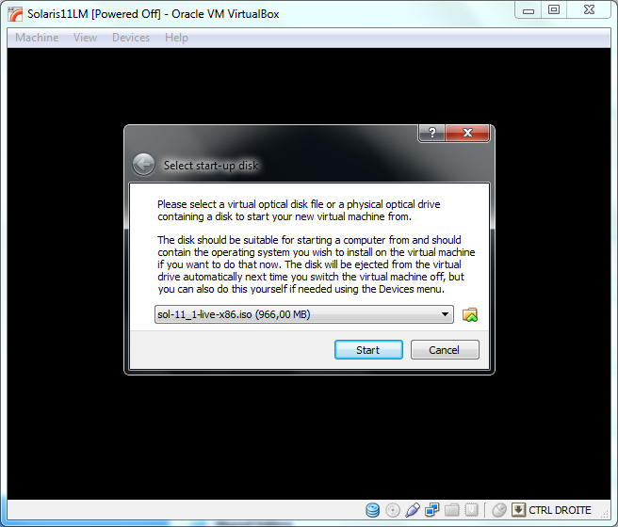
From the grub boot menu, choose the Oracle Solaris 11.1 item and hit ↵ Enter:
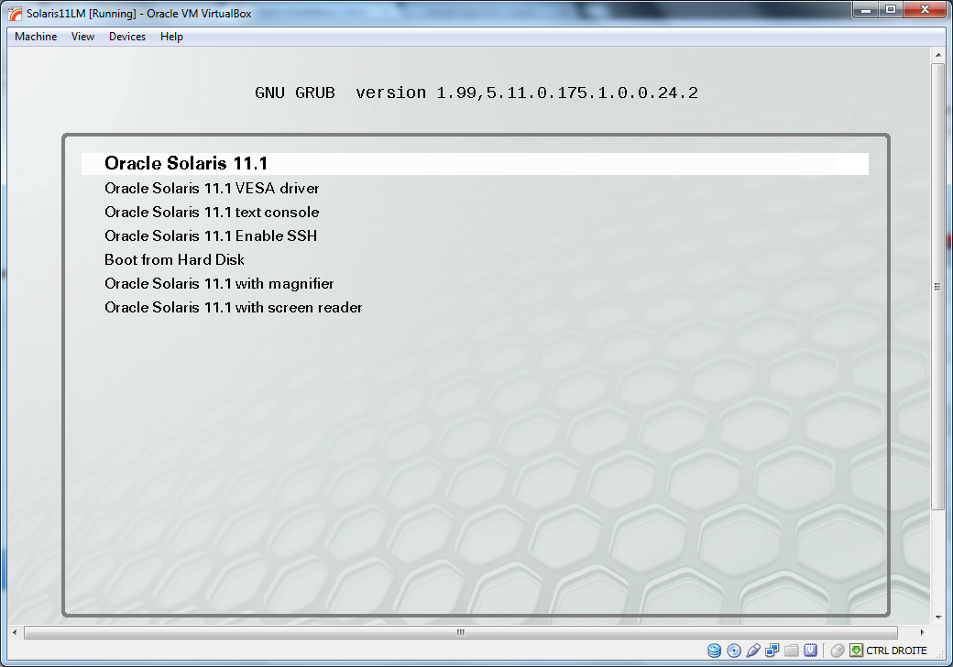
The Live system will boot:
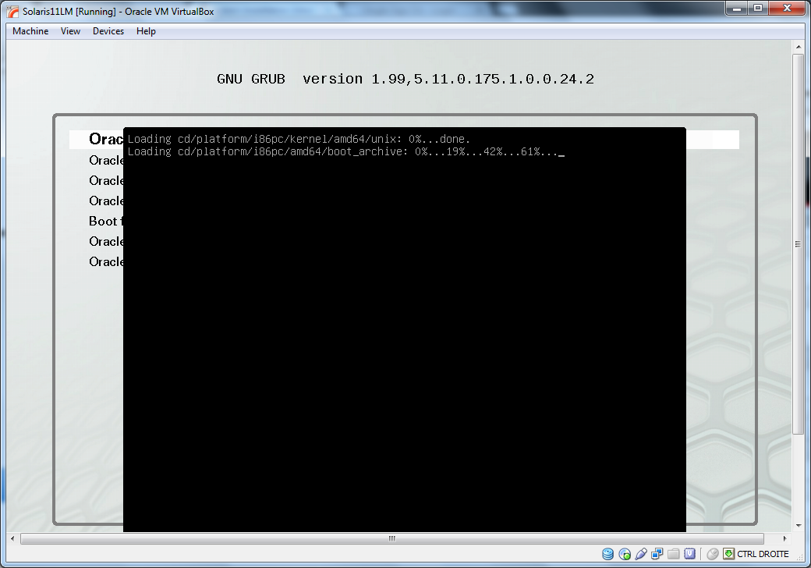
The system now prompts you to choose a keyboard layout:
Followed by the choice of the installation language:
When the system asks you to log in at the command line, do NOTHING. Wait until the graphical interface launches.
Once the graphical interface has launched, double click on the Device Driver Utility icon and click on the OK button to run the program as root. When prompted enter solaris as the root password:
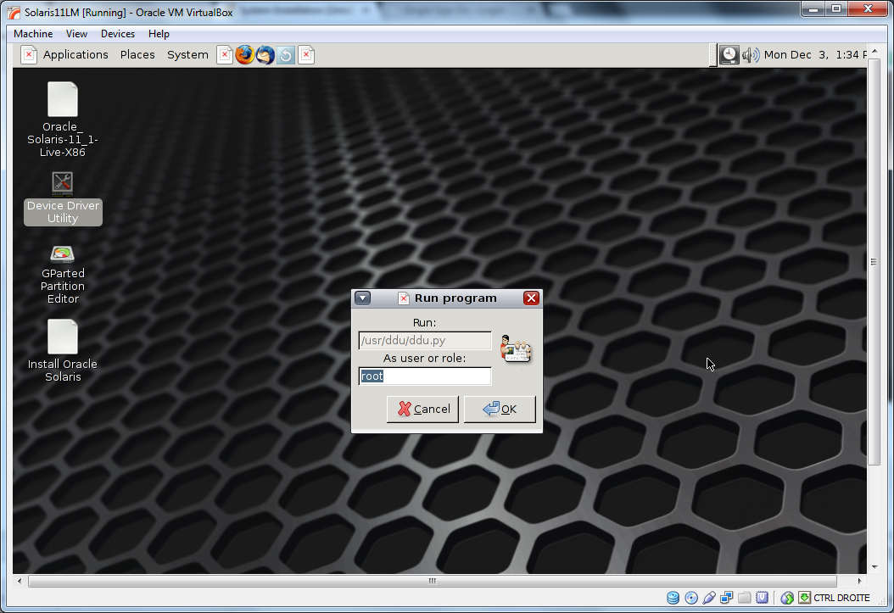
After a little while, the Device Driver Utility will show you any eventual driver problems:
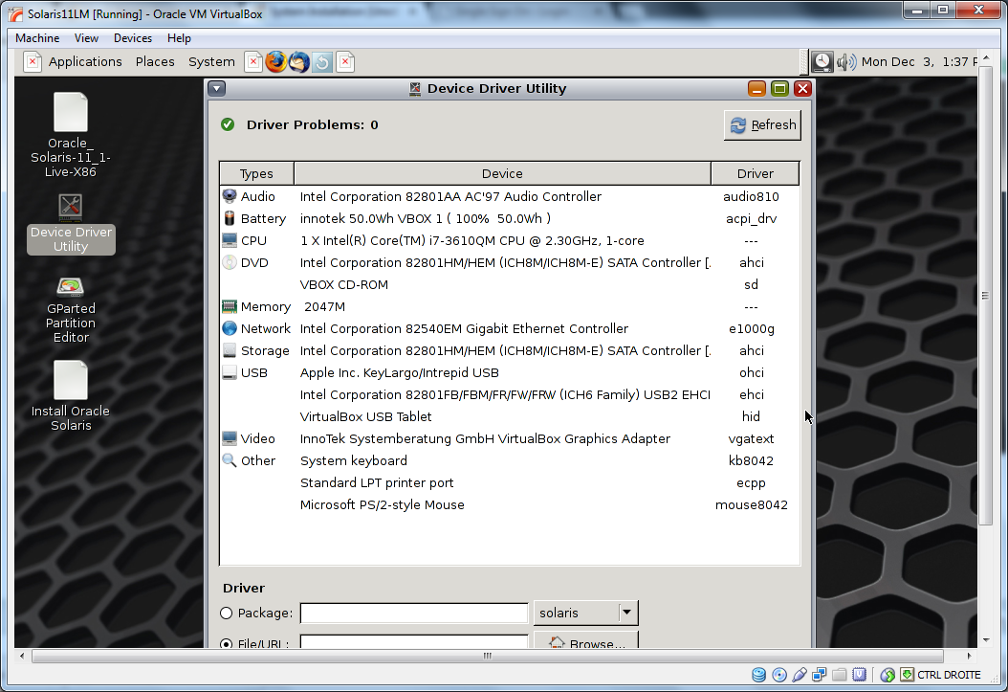
Close the Device Driver Utility window and double-click on the GParted Partition Editor icon. Using this application you can make space on a disk that already contains a Linux system in order to install Solaris 11:
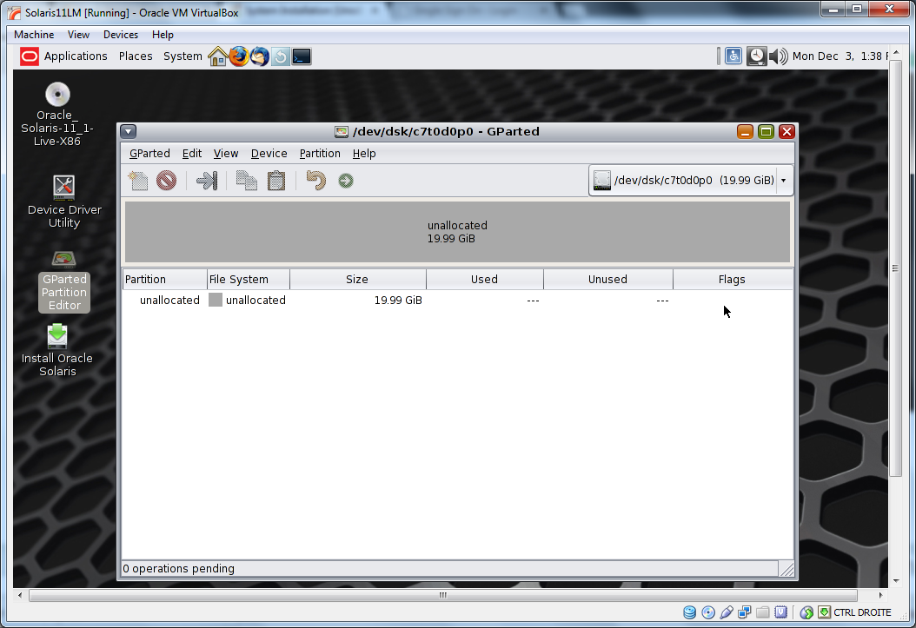
Close the GParted window and double-click on the Install Oracle Solaris icon:
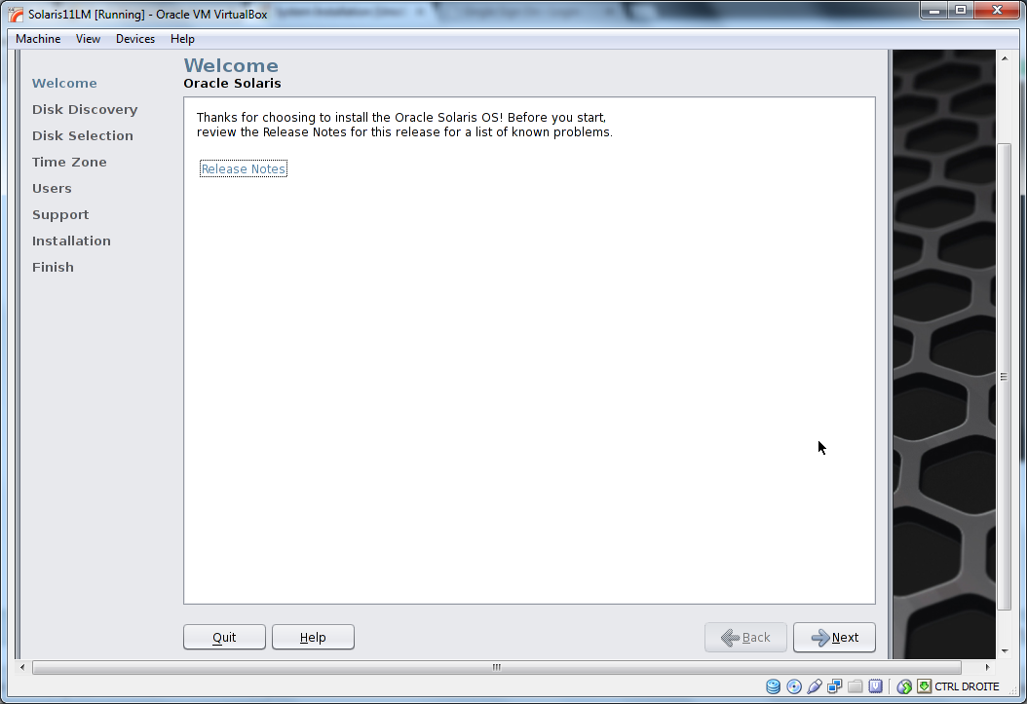
Using what you have learnt in the Text Install section of this lesson, install Solaris 11 using the Live Media. Once installed, log in, open a terminal and try to switch to the root role. Note that the root password has expired. Set the new root password to wind0w$. Finally install the VirtualBox Additions.

<html> <div align=“center”> Copyright © 2019 Hugh Norris. </html>

