Version - 2025.01
Last update :

DOE305 - Network, Service and Microservices Architecture Management

Curriculum
- DOE305 - Network, Service and Microservices Architecture Management
  - Curriculum
  - LAB #1 - Network and Service Management
    - 1.1 - Overview of Network Extensions
    - 1.2 - DNS K8s
      - Overview
      - Implementation
    - 1.3 - Network Policies
      - Overview
      - Implementation
    - 1.4 - Services
      - Overview
      - Implementation
        - The NodePort service
        - The ClusterIP service
    - 1.5 - Services and the K8s DNS
      - Overview
      - Implementation
    - 1.6 - K8s Ingress management
      - Overview
      - Implementation
  - LAB #2 - Microservices Architecture Management
    - 2.1 - Overview
    - 2.2 - Creating Deployments
    - 2.3 - Creating Services
    - 2.4 - Deploying the Application
    - 2.5 - Scaling Up

LAB #1 - Network and Service Management

1.1 - Overview of Network Extensions
Kubernetes imposes certain conditions on the implementation of a network:
- PODs on one node can communicate with all PODs on all nodes without using NAT,
- Agents on a node (e.g. kubelet) can communicate with all PODs on the node.
Important: A detailed technical description of the Kubernetes networking approach can be found at : https://kubernetes.io/docs/concepts/cluster-administration/networking/.
When installing the cluster, we specified the use of a network extension called Calico, taken from the following list:
- Calico,
- Cilium,
- Flannel,
- Kube-router,
- Romana,
- WeaveNet,
- Antrea,
- kube-ovn,
- Channel (uses Flannel for network and Calico for firewall).
Important: A comparative study of network extensions for Kubernetes can be found at : https://itnext.io/benchmark-results-of-kubernetes-network-plugins-cni-over-10gbit-s-network-updated-august-2020-6e1b757b9e49.

1.2 - DNS K8s

Overview
DNS services for the cluster using the Calico plugin are provided by CoreDNS :
root@kubemaster:~# kubectl get deployments -n kube-system
NAME READY UP-TO-DATE AVAILABLE AGE
calico-kube-controllers 1/1 1 1 12d
coredns 2/2 2 2 12d
metrics-server 1/1 1 1 11d
root@kubemaster:~# kubectl get service -n kube-system
NAME TYPE CLUSTER-IP EXTERNAL-IP PORT(S) AGE
kube-dns ClusterIP 10.96.0.10 <none> 53/UDP,53/TCP,9153/TCP 12d
metrics-server ClusterIP 10.98.89.81 <none> 443/TCP 11d
All pods are assigned a host name in the following format:
pod_ip_address_formated_as_xxx-xxx-xxx-xxx.namespace.pod.cluster.local

Implementation
To test the DNS, create the file dnstest.yaml:
To do: Copy the content from here and paste it into your file.
root@kubemaster:~# vi dnstest.yaml
root@kubemaster:~# cat dnstest.yaml
apiVersion: v1
kind: Pod
metadata:
name: busybox-dnstest
spec:
containers:
- name: busybox
image: radial/busyboxplus:curl
command: ['sh', '-c', 'while true; do sleep 3600; done']
---
apiVersion: v1
kind: Pod
metadata:
name: nginx-dnstest
spec:
containers:
- name: nginx
image: nginx:1.19.2
ports:
- containerPort: 80
Important: Note that this file will create two pods - busybox-dnstest and nginx-dnstest.
Create the two pods using the file:
root@kubemaster:~# kubectl create -f dnstest.yaml
pod/busybox-dnstest created
pod/nginx-dnstest created
Copy the IP address of the nginx-test pod:
root@kubemaster:~# kubectl get pods nginx-dnstest -o wide
NAME READY STATUS RESTARTS AGE IP NODE NOMINATED NODE READINESS GATES
nginx-dnstest 1/1 Running 0 48s 192.168.150.33 kubenode2.ittraining.loc <none> <none>
Run the curl <copied IP address> command in the busybox-dnstest container:
root@kubemaster:~# kubectl exec busybox-dnstest -- curl 192.168.150.33
% Total % Received % Xferd Average Speed Time Time Time Current
Dload Upload Total Spent Left Speed
0 0 0 0 0 0 0 0 --:--:-- --:--:-- --:--:-- 0<!DOCTYPE html>
<html>
<head>
<title>Welcome to nginx!</title>
...
</head>
<body>
<h1>Welcome to nginx!</h1>
<p>If you see this page, the nginx web server is successfully installed and
working. Further configuration is required.</p>
<p>For online documentation and support please refer to
<a href="http://nginx.org/">nginx.org</a>.<br/>
Commercial support is available at
<a href="http://nginx.com/">nginx.com</a>.</p>
<p><em>Thank you for using nginx.</em></p>
</body>
</html>
100 612 100 612 0 0 533k 0 --:--:-- --:--:-- --:--:-- 597k
Important: Note that busybox-dnstest was able to contact nginx-dnstest using its IP address.
Now use K8s DNS to resolve the nginx-dnstest pod hostname:
root@kubemaster:~# kubectl exec busybox-dnstest -- nslookup 192-168-150-33.default.pod.cluster.local
Server: 10.96.0.10
Address 1: 10.96.0.10 kube-dns.kube-system.svc.cluster.local
Name: 192-168-150-33.default.pod.cluster.local
Address 1: 192.168.150.33
Important: Note that the host name has been resolved using K8s DNS.
Now run the curl <hostname_of_pod_nginx_dnstest> command in the busybox-dnstest container:
root@kubemaster:~# kubectl exec busybox-dnstest -- curl 192-168-150-33.default.pod.cluster.local
% Total % Received % Xferd Average Speed Time Time Time Current
Dload Upload Total Spent Left Speed
0 0 0 0 0 0 0 0 --:--:-- --:--:-- --:--:-- 0
...
<title>Welcome to nginx!</title>
...
100 612 100 612 0 0 355k 0 --:--:-- --:--:-- --:--:-- 597k
Important: Note that busybox-dnstest was able to contact nginx-dnstest using its host name.

1.3 - Network Policies

Overview
A NetworkPolicy is a K8s object that controls communication to and from pods.
The components of a NetworkPolicy are :
- from and to Selectors,
  - the from selector operates on Ingress traffic,
    - the word Ingress indicates network traffic to a pod,
  - the to selector operates on Egress traffic,
    - Egress indicates traffic received from a pod.
From and to Selectors use Types:
- podSelector,
  - A podSelector can select pods using Labels,
  - by default, a pod is not isolated in the cluster. However, as soon as a podSelector selects a pod, it is considered isolated and can only communicate using NetworkPolicies,
- namespaceSelector,
  - a namespaceSelector can select nameSpaces using Labels,
- ipBlock,
  - an IPBlock can select pods using a range of IP addresses in CIDR format.
In addition to the above Types, it is also possible to specify :
- Ports,
  - ports specify the port number and protocol,
  - network traffic is only accepted if the rules specified by Type and the port/protocol are satisfied.

Implementation
To understand this better, create a NameSpace called nptest :
root@kubemaster:~# kubectl create namespace nptest
namespace/nptest created
Label this NameSpace :
root@kubemaster:~# kubectl label namespace nptest lab=nptest
namespace/nptest labeled
Important: Note the label lab=nptest.
Now create the npnginx.yaml file:
To do: Copy the content from here and paste it into your file.
root@kubemaster:~# vi npnginx.yaml
root@kubemaster:~# cat npnginx.yaml
apiVersion: v1
kind: Pod
metadata:
name: npnginx
namespace: nptest
labels:
app: nginx
spec:
containers:
- name: nginx
image: nginx
Important: Note the app: nginx tag.
Create the npnginx pod:
root@kubemaster:~# kubectl create -f npnginx.yaml
pod/npnginx created
Now create the npbusybox.yaml file:
To do: Copy the content from here and paste it into your file.
root@kubemaster:~# vi npbusybox.yaml
root@kubemaster:~# cat npbusybox.yaml
apiVersion: v1
kind: Pod
metadata:
name: npbusybox
namespace: nptest
labels:
app: client
spec:
containers:
- name: busybox
image: radial/busyboxplus:curl
command: ['sh', '-c', 'while true; do sleep 5; done']
Important: Note the app: client label.
Create the npbusybox pod:
root@kubemaster:~# kubectl create -f npbusybox.yaml
pod/npbusybox created
View the information on the two pods created:
root@kubemaster:~# kubectl get pods -n nptest -o wide
NAME READY STATUS RESTARTS AGE IP NODE NOMINATED NODE READINESS GATES
npbusybox 1/1 Running 0 48s 192.168.150.35 kubenode2.ittraining.loc <none> <none>
npnginx 1/1 Running 0 4m13s 192.168.239.33 kubenode1.ittraining.loc <none> <none>
Copy the IP address of the npnginx node and create a variable called NGINX_IP :
root@kubemaster:~# NGINX_IP=192.168.239.33
root@kubemaster:~# echo $NGINX_IP
192.168.239.33
Test the communication between npbusybox and npnginx :
root@kubemaster:~# kubectl exec -n nptest npbusybox -- curl $NGINX_IP
% Total % Received % Xferd Average Speed Time Time Time Current
Dload Upload Total Spent Left Speed
100 615 100 615 0 0 78977 0 --:--:-- --:--:-- --:--:-- 87857
<!DOCTYPE html>
<html>
<head>
<title>Welcome to nginx!</title>
...
</head>
<body>
<h1>Welcome to nginx!</h1>
<p>If you see this page, the nginx web server is successfully installed and
working. Further configuration is required.</p>
<p>For online documentation and support please refer to
<a href="http://nginx.org/">nginx.org</a>.<br/>
Commercial support is available at
<a href="http://nginx.com/">nginx.com</a>.</p>
<p><em>Thank you for using nginx.</em></p>
</body>
</html>
Important: Remember: by default, a pod is not isolated in the cluster. The communication was therefore successful.
Now create the mynetworkpolicy.yaml file:
To do: Copy the content from here and paste it into your file.
root@kubemaster:~# vi mynetworkpolicy.yaml
root@kubemaster:~# cat mynetworkpolicy.yaml
apiVersion: networking.k8s.io/v1
kind: NetworkPolicy
metadata:
name: mynetworkpolicy
namespace: nptest
spec:
podSelector:
matchLabels:
app: nginx
policyTypes:
- Ingress
- Egress
Important: Note the app: nginx tag. The policy therefore applies to the npnginx pod.
Now create the NetworkPolicy :
root@kubemaster:~# kubectl create -f mynetworkpolicy.yaml
networkpolicy.networking.k8s.io/mynetworkpolicy created
Test the communication between npbusybox and npnginx again:
root@kubemaster:~# kubectl exec -n nptest npbusybox -- curl $NGINX_IP
% Total % Received % Xferd Average Speed Time Time Time Current
Dload Upload Total Spent Left Speed
0 0 0 0 0 0 0 0 --:--:-- 0:00:24 --:--:-- 0^C
Important: Note that NetworkPolicy blocks communication. Also note the use of ^C to terminate the process.
Now edit the NetworkPolicy:
root@kubemaster:~# kubectl edit networkpolicy -n nptest mynetworkpolicy
# Please edit the object below. Lines beginning with a '#' will be ignored,
# and an empty file will abort the edit. If an error occurs while saving this file will be
# reopened with the relevant failures.
#
apiVersion: networking.k8s.io/v1
kind: NetworkPolicy
metadata:
creationTimestamp: "2022-09-16T13:24:29Z"
generation: 1
name: mynetworkpolicy
namespace: nptest
resourceVersion: "1490105"
uid: b130f09f-2ab1-4dc6-9059-95f900234be3
spec:
podSelector:
matchLabels:
app: nginx
policyTypes:
- Ingress
- Egress
ingress:
- from:
- namespaceSelector:
matchLabels:
lab: nptest
ports:
- protocol: TCP
port: 80
status: {}
:wq
root@kubemaster:~# kubectl edit networkpolicy -n nptest mynetworkpolicy
networkpolicy.networking.k8s.io/mynetworkpolicy edited
Important: Note the creation of the ingress rule. This rule uses a namespaceSelector to allow traffic from pods in a NameSpace with a lab: nptest label. The ports rule allows traffic on port 80/tcp.
Test communication between npbusybox and npnginx again:
root@kubemaster:~# kubectl exec -n nptest npbusybox -- curl $NGINX_IP
% Total % Received % Xferd Average Speed Time Time Time Current
Dload Upload Total Spent Left Speed
100 615 100 615 0 0 531k 0 --:--:-- --:--:-- --:--:-- 600k
<!DOCTYPE html>
<html>
<head>
<title>Welcome to nginx!</title>
...
</head>
<body>
<h1>Welcome to nginx!</h1>
<p>If you see this page, the nginx web server is successfully installed and
working. Further configuration is required.</p>
<p>For online documentation and support please refer to
<a href="http://nginx.org/">nginx.org</a>.<br/>
Commercial support is available at
<a href="http://nginx.com/">nginx.com</a>.</p>
<p><em>Thank you for using nginx.</em></p>
</body>
</html>
Important: Note that the communication was successful.

1.4 - Services

Overview
K8s services are:
- NodePort,
  - This service makes a POD accessible on a port of the node containing it,
- ClusterIP
  - This service creates a virtual IP address to enable communication between different services in the cluster, e.g. front-end servers with back-end servers,
- LoadBalancer
  - This service provides load balancing for an application in certain public Cloud providers such as Amazon Web Services and Google Cloud Platform.
- ExternalName
  - Not part of CKA certification.

Implementation
Start by creating the myapp-deployment :
root@kubemaster:~# kubectl create -f deployment-definition.yaml
deployment.apps/myapp-deployment created
Check the status of the pods:
root@kubemaster:~# kubectl get pods -o wide
NAME READY STATUS RESTARTS AGE IP NODE NOMINATED NODE READINESS GATES
busybox-dnstest 1/1 Running 0 4h9m 192.168.150.34 kubenode2.ittraining.loc <none> <none>
myapp-deployment-7c4d4f7fc6-2km9n 1/1 Running 0 83s 192.168.239.34 kubenode1.ittraining.loc <none> <none>
myapp-deployment-7c4d4f7fc6-7pts7 1/1 Running 0 83s 192.168.239.35 kubenode1.ittraining.loc <none> <none>
myapp-deployment-7c4d4f7fc6-9pw5x 1/1 Running 0 83s 192.168.150.36 kubenode2.ittraining.loc <none> <none>
mydaemonset-hmdhp 1/1 Running 1 (7h29m ago) 23h 192.168.239.32 kubenode1.ittraining.loc <none> <none>
mydaemonset-kmf4z 1/1 Running 1 23h 192.168.150.31 kubenode2.ittraining.loc <none> <none>
nginx-dnstest 1/1 Running 0 4h9m 192.168.150.33 kubenode2.ittraining.loc <none> <none>
Important: Note that the 192.168.239.x addresses are associated with PODs on kubenode1, while the 192.168.150.x addresses are associated with PODs on kubenode2. These addresses come from the 192.168.0.0/16 network stipulated by the –pod-network-cidr option during controller initialization.
Knowing that a Nginx container exists in each POD, test whether you can display the Nginx home page by connecting to kubenode1 and kubenode2 from your Gateway:
trainee@kubemaster:~$ exit
déconnexion
Connection to 10.0.2.65 closed.
trainee@gateway:~$ curl 192.168.56.3
curl: (7) Failed to connect to 192.168.56.3 port 80: Connection refused
trainee@gateway:~$ curl 192.168.56.4
curl: (7) Failed to connect to 192.168.56.4 port 80: Connection refused
Important: Note the connection failure.
Now test whether you can display the Nginx home page by connecting to one of the PODs from your Gateway :
trainee@gateway:~$ curl 192.168.239.34
^C
Connect to kubemaster :
trainee@gateway:~$ ssh -l trainee 192.168.56.2
trainee@192.168.56.2's password: trainee
Linux kubemaster.ittraining.loc 4.9.0-19-amd64 #1 SMP Debian 4.9.320-2 (2022-06-30) x86_64
The programs included with the Debian GNU/Linux system are free software;
the exact distribution terms for each program are described in the
individual files in /usr/share/doc/*/copyright.
Debian GNU/Linux comes with ABSOLUTELY NO WARRANTY, to the extent
permitted by applicable law.
Last login: Wed Jul 13 15:45:46 2022 from 10.0.2.40
trainee@kubemaster:~$ su -
Password: fenestros
root@kubemaster:~#
Of course, it is possible to display the page by connecting to one of the PODs inside the cluster:
root@kubemaster:~# curl 192.168.239.34
<!DOCTYPE html>
<html>
<head>
<title>Welcome to nginx!</title>
<style>
body {
width: 35em;
margin: 0 auto;
font-family: Tahoma, Verdana, Arial, sans-serif;
}
</style>
</head>
<body>
<h1>Welcome to nginx!</h1>
<p>If you see this page, the nginx web server is successfully installed and
working. Further configuration is required.</p>
<p>For online documentation and support please refer to
<a href="http://nginx.org/">nginx.org</a>.<br/>
Commercial support is available at
<a href="http://nginx.com/">nginx.com</a>.</p>
<p><em>Thank you for using nginx.</em></p>
</body>
</html>
Important: Note that at this stage, it is not possible to display the Nginx home page when connecting from outside the cluster.

The NodePort Service
The NodePort Service defines three ports:
- TargetPort: the port on the POD,
- Port: the port on the Service linked to a Cluster IP,
- NodePort : the port on the Node from the range 30000-32767.
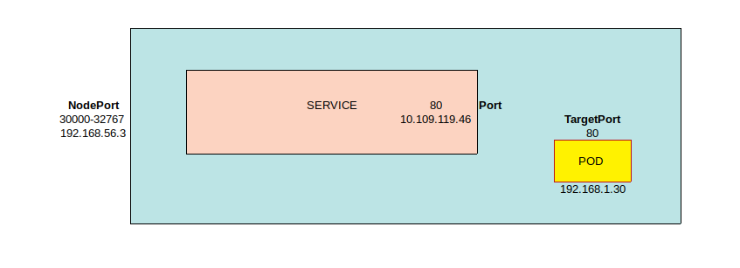
}
If several PODs in the same node have labels that match the Service's selector, the Service identifies the PODs and automatically expands to include all PODs. PODs are called End-Points:
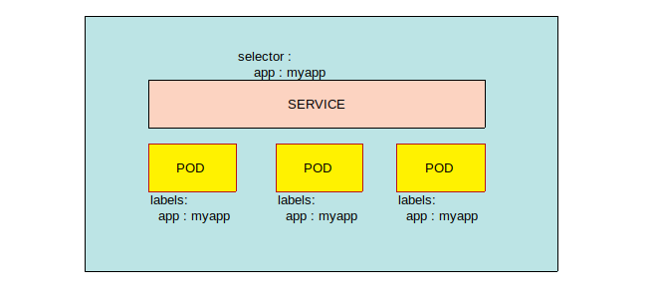
Important: Note that in this case, load balancing is automatic and uses the Random algorithm with a session affinity…
Similarly, when PODs are distributed across several nodes, the Service extends to encompass all of them:
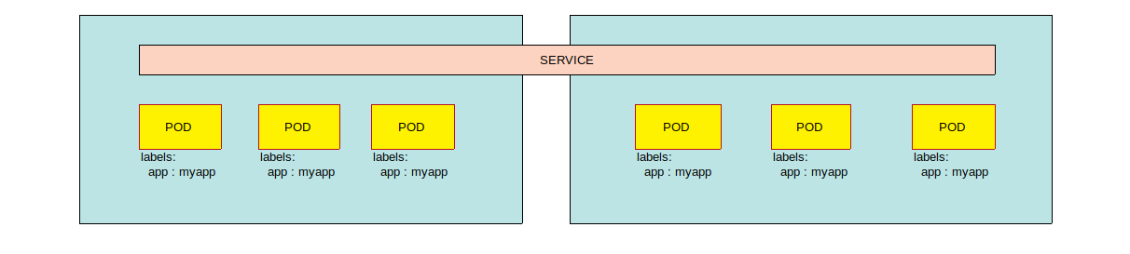
Create the YAML file service-definition.yaml :
To do: Copy the content from here and paste it into your file.
root@kubemaster:~# vi service-definition.yaml
root@kubemaster:~# cat service-definition.yaml
apiVersion: v1
kind: Service
metadata:
name: myapp-service
spec:
type: NodePort
ports:
- targetPort: 80
port: 80
nodePort: 30008
selector:
app: myapp
type: front-end
Important: Note that if the type: field is missing, its default value is ClusterIP. Also note that in ports, only the port field is mandatory. If the targetPort field is missing, its default value is that of the port field. If the nodePort field is missing, its default value is the first available port in the range 30,000 to 32,767. Finally, it is possible to specify multiple port definitions in the service.
The selector field contains the labels of the PODs concerned by the Service setup:
root@kubemaster:~# cat pod-definition.yaml
apiVersion: v1
kind: Pod
metadata:
name: myapp-pod
labels:
app: myapp
type: front-end
spec:
containers:
- name: nginx-container
image: nginx
Create the Service using the service-definition.yaml file:
root@kubemaster:~# kubectl create -f service-definition.yaml
service/myapp-service created
Note that the service has been created:
root@kubemaster:~# kubectl get services
NAME TYPE CLUSTER-IP EXTERNAL-IP PORT(S) AGE
kubernetes ClusterIP 10.96.0.1 <none> 443/TCP 26h
myapp-service NodePort 10.97.228.14 <none> 80:30008/TCP 13s
Important: Note that the Service has a cluster IP address and has exposed port 30,008.
Now test whether you can display the Nginx home page by connecting to one of the PODs from your Gateway using the exposed port:
root@kubemaster:~# exit
déconnexion
trainee@kubemaster:~$ exit
déconnexion
Connection to 192.168.56.2 closed.
trainee@gateway:~$ curl 192.168.56.3:30008
<!DOCTYPE html>
<html>
<head>
<title>Welcome to nginx!</title>
<style>
body {
width: 35em;
margin: 0 auto;
font-family: Tahoma, Verdana, Arial, sans-serif;
}
</style>
</head>
<body>
<h1>Welcome to nginx!</h1>
<p>If you see this page, the nginx web server is successfully installed and
working. Further configuration is required.</p>
<p>For online documentation and support please refer to
<a href="http://nginx.org/">nginx.org</a>.<br/>
Commercial support is available at
<a href="http://nginx.com/">nginx.com</a>.</p>
<p><em>Thank you for using nginx.</em></p>
</body>
</html>
trainee@gateway:~$ curl 192.168.56.4:30008
<!DOCTYPE html>
<html>
<head>
<title>Welcome to nginx!</title>
<style>
body {
width: 35em;
margin: 0 auto;
font-family: Tahoma, Verdana, Arial, sans-serif;
}
</style>
</head>
<body>
<h1>Welcome to nginx!</h1>
<p>If you see this page, the nginx web server is successfully installed and
working. Further configuration is required.</p>
<p>For online documentation and support please refer to
<a href="http://nginx.org/">nginx.org</a>.<br/>
Commercial support is available at
<a href="http://nginx.com/">nginx.com</a>.</p>
<p><em>Thank you for using nginx.</em></p>
</body>
</html>

The ClusterIP Service
The ClusterIP service groups together PODs offering the same service to facilitate communication between pods within the cluster.
To create a ClusterIP Service, create the file clusterip-example.yaml:
To do: Copy the content from here and paste it into your file.
root@kubemaster:~# vi clusterip-example.yaml
root@kubemaster:~# cat clusterip-example.yaml
apiVersion: apps/v1
kind: Deployment
metadata:
name: deploymentclusterip
spec:
replicas: 3
selector:
matchLabels:
app: clusteripexample
template:
metadata:
labels:
app: clusteripexample
spec:
containers:
- name: nginx
image: nginx:1.19.1
ports:
- containerPort: 80
Create a deployment using the clusterip-example.yaml file:
root@kubemaster:~# kubectl create -f clusterip-example.yaml
deployment.apps/deploymentclusterip created
Now create a ClusterIP service to expose the pods in the deploymentclusterip deplyment:
To do: Copy the content from here and paste it into your file.
root@kubemaster:~# vi clusterip-service.yaml
root@kubemaster:~# cat clusterip-service.yaml
apiVersion: v1
kind: Service
metadata:
name: clusteripservice
spec:
type: ClusterIP
selector:
app: clusteripexample
ports:
- protocol: TCP
port: 80
targetPort: 80
Create a service using the clusterip-service.yaml file:
root@kubemaster:~# kubectl create -f clusterip-service.yaml
service/clusteripservice created
root@kubemaster:~# kubectl get services
NAME TYPE CLUSTER-IP EXTERNAL-IP PORT(S) AGE
clusteripservice ClusterIP 10.109.80.217 <none> 80/TCP 5s
kubernetes ClusterIP 10.96.0.1 <none> 443/TCP 12d
View the service's EndPoints using the following command:
root@kubemaster:~# kubectl get endpoints clusteripservice
NAME ENDPOINTS AGE
clusteripservice 192.168.150.39:80,192.168.150.40:80,192.168.239.38:80 114s
Now create a pod that will use the clusteripservice service:
To do: Copy the content from here and paste it into your file.
root@kubemaster:~# vi clusterippod.yaml
root@kubemaster:~# cat clusterippod.yaml
apiVersion: v1
kind: Pod
metadata:
name: clusterippod
spec:
containers:
- name: busybox
image: radial/busyboxplus:curl
command: ['sh', '-c', 'while true; do sleep 10; done']
Create the pod using the clusterippod.yaml file:
root@kubemaster:~# kubectl create -f clusterippod.yaml
pod/clusterippod created
Check that the clusterippod pod is running:
root@kubemaster:~# kubectl get pod clusterippod
NAME READY STATUS RESTARTS AGE
clusterippod 1/1 Running 0 2m28s
Check the clusteripservice inside the clusterippod pod:
root@kubemaster:~# kubectl exec clusterippod -- curl clusteripservice
% Total % Received % Xferd Average Speed Time Time Time Current
Dload Upload Total Spent Left Speed
0 0 0 0 0 0 0 0 --:--:-- --:--:-- --:--:-- 0<!DOCTYPE html>
<html>
<head>
<title>Welcome to nginx!</title>
...
</head>
<body>
<h1>Welcome to nginx!</h1>
<p>If you see this page, the nginx web server is successfully installed and
working. Further configuration is required.</p>
<p>For online documentation and support please refer to
<a href="http://nginx.org/">nginx.org</a>.<br/>
Commercial support is available at
<a href="http://nginx.com/">nginx.com</a>.</p>
<p><em>Thank you for using nginx.</em></p>
</body>
</html>
100 612 100 612 0 0 6224 0 --:--:-- --:--:-- --:--:-- 6652

1.5 - Services and the k8s DNS
Before continuing, clean up the cluster:
root@kubemaster:~# kubectl delete service myapp-service
service “myapp-service” deleted
root@kubemaster:~# kubectl delete deployment myapp-deployment
deployment.extensions “myapp-deployment” deleted
root@kubemaster:~# kubectl delete daemonset mydaemonset
daemonset.apps “mydaemonset” deleted
root@kubemaster:~# kubectl delete pods busybox-dnstest nginx-dnstest
pod “busybox-dnstest” deleted
pod “nginx-dnstest” deleted

Overview
Each K8s service is assigned a FQDN in the form :
service-name.namespace.svc.cluster-name-domain.example
Note that :
- The default cluster-domain-name.example is cluster.local.
- The FQDN can be used to reach a service from any NameSpace.
- Pods in the same NameSpace as the service can reach it using its short name, i.e. service-name.

Implementation
View the clusteripservice service created earlier:
root@kubemaster:~# kubectl get service clusteripservice
NAME TYPE CLUSTER-IP EXTERNAL-IP PORT(S) AGE
clusteripservice ClusterIP 10.109.80.217 <none> 80/TCP 12m
as well as the pods present in the cluster:
root@kubemaster:~# kubectl get pods
NAME READY STATUS RESTARTS AGE
clusterippod 1/1 Running 0 11m
deploymentclusterip-7776dc8d55-bmfjl 1/1 Running 0 15m
deploymentclusterip-7776dc8d55-pgmcg 1/1 Running 0 15m
deploymentclusterip-7776dc8d55-qvphh 1/1 Running 0 15m
View the FQDN of the clusteripservice using the clusterippod pod:
root@kubemaster:~# kubectl exec clusterippod -- nslookup 10.109.80.217
Server: 10.96.0.10
Address 1: 10.96.0.10 kube-dns.kube-system.svc.cluster.local
Name: 10.109.80.217
Address 1: 10.109.80.217 clusteripservice.default.svc.cluster.local
Important: Note that the FQDN of the service is clusteripservice.default.svc.cluster.local.
Check communication with the service using its IP address:
root@kubemaster:~# kubectl exec clusterippod -- curl 10.109.80.217
% Total % Received % Xferd Average Speed Time Time Time Current
Dload Upload Total Spent Left Speed
100 612 100 612 0 0 35322 0 --:--:--<!DOCTYPE html>:-- 0
<html>
<head>
<title>Welcome to nginx!</title>
<style>
body {
width: 35em;
margin: 0 auto;
font-family: Tahoma, Verdana, Arial, sans-serif;
}
</style>
</head>
<body>
<h1>Welcome to nginx!</h1>
<p>If you see this page, the nginx web server is successfully installed and
working. Further configuration is required.</p>
<p>For online documentation and support please refer to
<a href="http://nginx.org/">nginx.org</a>.<br/>
Commercial support is available at
<a href="http://nginx.com/">nginx.com</a>.</p>
<p><em>Thank you for using nginx.</em></p>
</body>
</html>
--:--:-- --:--:-- 36000
Check the communication with the service using its short name:
root@kubemaster:~# kubectl exec clusterippod -- curl clusteripservice
% Total % Received % Xferd Average Speed Time Time Time Current
Dload Upload Total Spent Left Speed
100 612 100 612 0 0 81404 0 --:--:-- --:--:-- --:--:-- 597k
<!DOCTYPE html>
<html>
<head>
<title>Welcome to nginx!</title>
<style>
body {
width: 35em;
margin: 0 auto;
font-family: Tahoma, Verdana, Arial, sans-serif;
}
</style>
</head>
<body>
<h1>Welcome to nginx!</h1>
<p>If you see this page, the nginx web server is successfully installed and
working. Further configuration is required.</p>
<p>For online documentation and support please refer to
<a href="http://nginx.org/">nginx.org</a>.<br/>
Commercial support is available at
<a href="http://nginx.com/">nginx.com</a>.</p>
<p><em>Thank you for using nginx.</em></p>
</body>
</html>
Important: Note that the communication was successful because the clusterippod pod and the clusteripservice service are in the same namespace.
Verify the communication with the service using its FQDN:
root@kubemaster:~# kubectl exec clusterippod -- curl clusteripservice.default.svc.cluster.local
% Total % Received % Xferd Average Speed Time Time Time Current
Dload Upload Total Spent Left Speed
100 612 100 612 0 0 269k 0 --:--:-- --:--:-- --:--:-- 597k
<!DOCTYPE html>
<html>
<head>
<title>Welcome to nginx!</title>
<style>
body {
width: 35em;
margin: 0 auto;
font-family: Tahoma, Verdana, Arial, sans-serif;
}
</style>
</head>
<body>
<h1>Welcome to nginx!</h1>
<p>If you see this page, the nginx web server is successfully installed and
working. Further configuration is required.</p>
<p>For online documentation and support please refer to
<a href="http://nginx.org/">nginx.org</a>.<br/>
Commercial support is available at
<a href="http://nginx.com/">nginx.com</a>.</p>
<p><em>Thank you for using nginx.</em></p>
</body>
</html>
Now check the communication with the service using its short name from the npbusybox pod in the nptest namespace:
root@kubemaster:~# kubectl exec -n nptest npbusybox -- curl clusteripservice
curl: (6) Couldn't resolve host 'clusteripservice'
command terminated with exit code 6
Important: Note that the communication was unsuccessful because the npbusybox pod and the clusteripservice service are not in the same namespace.
Now check the communication with the service using its FQDN from the npbusybox pod in the nptest namespace:
root@kubemaster:~# kubectl exec -n nptest npbusybox -- curl clusteripservice.default.svc.cluster.local
% Total % Received % Xferd Average Speed Time Time Time Current
Dload Upload Total Spent Left Speed
100 612 100 612 0 0 291k 0 --:--:-- --:--:-- --:--:-- 597k
<!DOCTYPE html>
<html>
<head>
<title>Welcome to nginx!</title>
<style>
body {
width: 35em;
margin: 0 auto;
font-family: Tahoma, Verdana, Arial, sans-serif;
}
</style>
</head>
<body>
<h1>Welcome to nginx!</h1>
<p>If you see this page, the nginx web server is successfully installed and
working. Further configuration is required.</p>
<p>For online documentation and support please refer to
<a href="http://nginx.org/">nginx.org</a>.<br/>
Commercial support is available at
<a href="http://nginx.com/">nginx.com</a>.</p>
<p><em>Thank you for using nginx.</em></p>
</body>
</html>
Important: Note that the communication was successful thanks to the use of the service's FQDN.

1.6 - K8s Ingress management

Overview
An Ingress is a K8s object that manages access to services from outside the cluster. An Ingress is capable of more functionality than a simple NodePort service, for example:
- SSL,
- load balancing,
- name-based virtual hosts.
Ingress doesn't do anything on its own. It needs an Ingress Controller to function. Setting up and configuring an Ingress Controller is not part of the CKA certification.

Implementation
Start by creating the myingress.yaml file:
To do: Copy the content from here and paste it into your file.
root@kubemaster:~# vi myingress.yaml
root@kubemaster:~# cat myingress.yaml
apiVersion: networking.k8s.io/v1
kind: Ingress
metadata:
name: my-ingress
spec:
rules:
- http:
paths:
- path: /somepath
pathType: Prefix
backend:
service:
name: clusteripservice
port:
number: 80
Important: Note that in this Ingress file we have a rule that defines a path. Requests that reference the path, for example http://<endpoint>/somepath, will be routed to the backend. In this example, the backend is a service, clusteripservice, listening on port 80.
Now create the Ingress :
root@kubemaster:~# kubectl create -f myingress.yaml
ingress.networking.k8s.io/my-ingress created
Now consult Ingress:
root@kubemaster:~# kubectl describe ingress my-ingress
Name: my-ingress
Labels: <none>
Namespace: default
Address:
Ingress Class: <none>
Default backend: <default>
Rules:
Host Path Backends
---- ---- --------
*
/somepath clusteripservice:80 (192.168.150.39:80,192.168.150.40:80,192.168.239.38:80)
Annotations: <none>
Events: <none>
Important: Note that the endpoints of the clusteripservice are displayed in the command output.
Now edit the clusterip-service.yaml file and add a name line in the ports section:
root@kubemaster:~# vi clusterip-service.yaml
root@kubemaster:~# cat clusterip-service.yaml
apiVersion: v1
kind: Service
metadata:
name: clusteripservice
spec:
type: ClusterIP
selector:
app: clusteripexample
ports:
- name: myingress
protocol: TCP
port: 80
targetPort: 80
Important: Note that the name can be any string.
Apply the clusteripservice modification:
root@kubemaster:~# kubectl apply -f clusterip-service.yaml
Warning: resource services/clusteripservice is missing the kubectl.kubernetes.io/last-applied-configuration annotation which is required by kubectl apply. kubectl apply should only be used on resources created declaratively by either kubectl create --save-config or kubectl apply. The missing annotation will be patched automatically.
service/clusteripservice configured
Important: Note that the error is unimportant.
Now edit the myingress.yaml file and add a name line in the ports section, deleting the number: 80 line:
root@kubemaster:~# cat myingress.yaml
apiVersion: networking.k8s.io/v1
kind: Ingress
metadata:
name: my-ingress
spec:
rules:
- http:
paths:
- path: /somepath
pathType: Prefix
backend:
service:
name: clusteripservice
port:
name: myingress
Apply the Ingress modification:
root@kubemaster:~# kubectl apply -f myingress.yaml
Warning: resource ingresses/my-ingress is missing the kubectl.kubernetes.io/last-applied-configuration annotation which is required by kubectl apply. kubectl apply should only be used on resources created declaratively by either kubectl create --save-config or kubectl apply. The missing annotation will be patched automatically.
ingress.networking.k8s.io/my-ingress configured
Important: Note that the error is unimportant.
Now check the Ingress :
root@kubemaster:~# kubectl describe ingress my-ingress
Name: my-ingress
Labels: <none>
Namespace: default
Address:
Ingress Class: <none>
Default backend: <default>
Rules:
Host Path Backends
---- ---- --------
*
/somepath clusteripservice:myingress (192.168.150.39:80,192.168.150.40:80,192.168.239.38:80)
Annotations: <none>
Events: <none>
Important: Note that Ingress can still find the backend by using the name myingress.

LAB #2 - Managing a Microservices Architecture
Before continuing, clean up the cluster:
root@kubemaster:~# kubectl delete service clusteripservice
service “clusteripservice” deleted
root@kubemaster:~# kubectl delete deployment deploymentclusterip
deployment.apps “deploymentclusterip” deleted
root@kubemaster:~# kubectl delete ingress my-ingress
ingress.networking.k8s.io “my-ingress” deleted
root@kubemaster:~# kubectl delete pod clusterippod
pod “clusterippod” deleted
Check that only the default kubernetes service remains:
root@kubemaster:~# kubectl get all
NAME TYPE CLUSTER-IP EXTERNAL-IP PORT(S) AGE
service/kubernetes ClusterIP 10.96.0.1 <none> 443/TCP 13d

2.1 - Overview
You're going to set up a simple application in the form of microservices, developed by Docker, and called demo-voting-app:
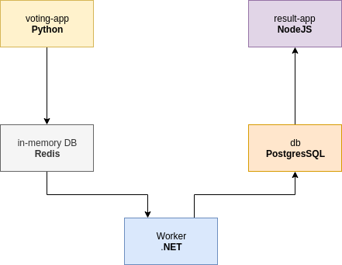
In this application, the voting-app container lets you vote for cats or dogs. This application runs under Python and provides an HTML interface:
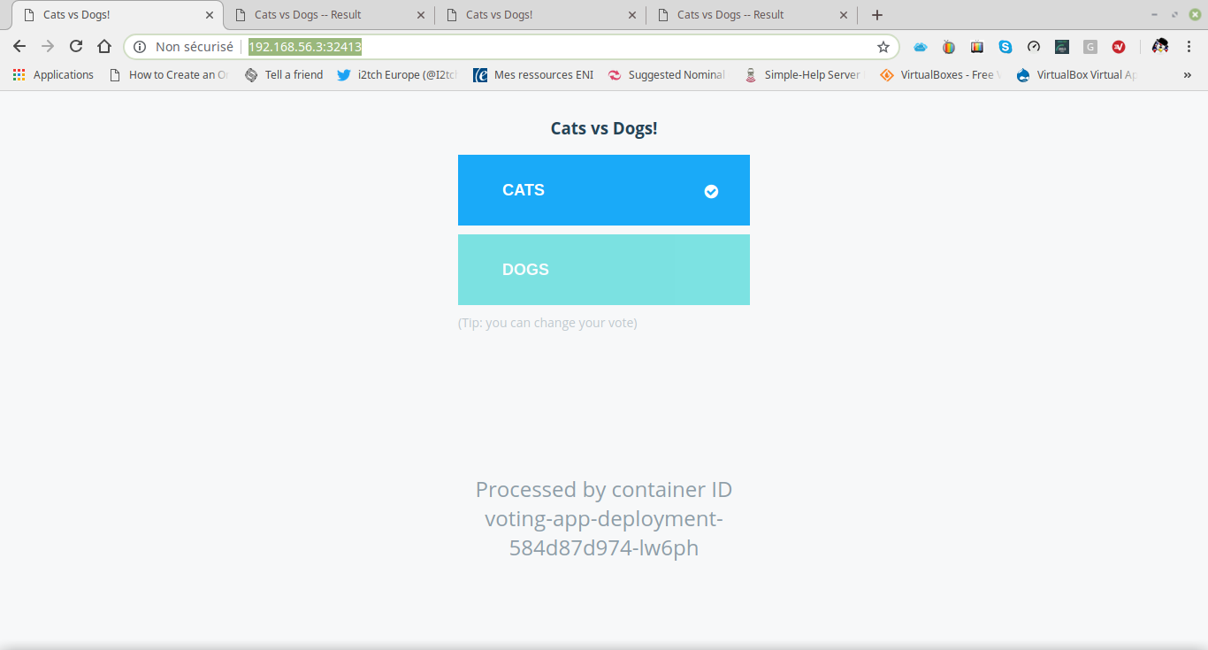
}
When voting, the result is stored in Redis in an in-memory database. The result is then passed to the Worker container running under .NET, which updates the persistent database in the db container running under PostgreSQL.
The result-app application running under NodeJS then reads the table from the PostgreSQL database and displays the result in HTML form:
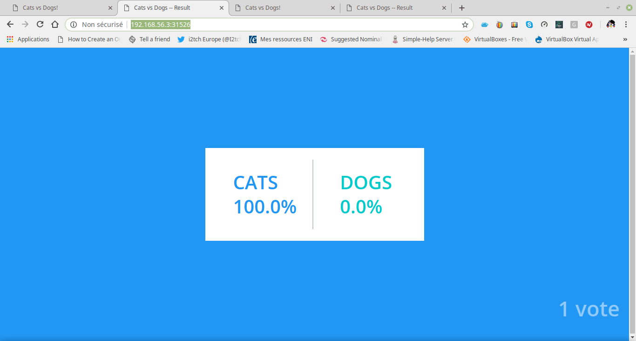
}

2.2 - Creating Deployments
Create the myapp directory. Go to this directory and create the file voting-app-deployment.yaml:
To do: Copy the content from here and paste it into your file.
root@kubemaster:~# mkdir myapp
root@kubemaster:~# cd myapp
root@kubemaster:~/app# vi voting-app-deployment.yaml
root@kubemaster:~/app# cat voting-app-deployment.yaml
---
apiVersion: apps/v1
kind: Deployment
metadata:
name: voting-app-deployment
labels:
app: demo-voting-app
spec:
replicas: 1
selector:
matchLabels:
name: voting-app-pod
app: demo-voting-app
template:
metadata:
name: voting-app-pod
labels:
name: voting-app-pod
app: demo-voting-app
spec:
containers:
- name: voting-app
image: dockersamples/examplevotingapp_vote
ports:
- containerPort: 80
Important : This file describes a Deployment. Note that the Deployment creates a replica of the POD specified by template containing a container named voting-app which uses port 80 and is created from the image dockersamples/examplevotingapp_vote.
Now create the redis-deployment.yaml file:
To do: Copy the content from here and paste it into your file.
root@kubemaster:~/app# vi redis-deployment.yaml
root@kubemaster:~/app# cat redis-deployment.yaml
---
apiVersion: apps/v1
kind: Deployment
metadata:
name: redis-deployment
labels:
app: demo-voting-app
spec:
replicas: 1
selector:
matchLabels:
name: redis-pod
app: demo-voting-app
template:
metadata:
name: redis pod
labels:
name: redis-pod
app: demo-voting-app
spec:
containers:
- name: redis
image: redis
ports:
- containerPort: 6379
Important : This file describes a Deployment. Note that the Deployment creates a replica of the POD specified by template containing a container named redis which uses port 6379 and is created from the redis image.
Create the file worker-deployment.yaml:
To do: Copy the content from here and paste it into your file.
root@kubemaster:~/app# vi worker-deployment.yaml
root@kubemaster:~/app# cat worker-deployment.yaml
---
apiVersion: apps/v1
kind: Deployment
metadata:
name: worker-app-deployment
labels:
app: demo-voting-app
spec:
replicas: 1
selector:
matchLabels:
name: worker-app-pod
app: demo-voting-app
template:
metadata:
name: worker-app-pod
labels:
name: worker-app-pod
app: demo-voting-app
spec:
containers:
- name: worker-app
image: dockersamples/examplevotingapp_worker
Important : This file describes a Deployment. Note that the Deployment creates a replica of the POD specified by template containing a container called worker-app which is created from the dockersamples/examplevotingapp_worker image.
Next, create the file postgres-deployment.yaml:
To do: Copy the content from here and paste it into your file.
root@kubemaster:~/app# vi postgres-deployment.yaml
root@kubemaster:~/app# cat postgres-deployment.yaml
---
apiVersion: apps/v1
kind: Deployment
metadata:
name: postgres-deployment
labels:
app: demo-voting-app
spec:
replicas: 1
selector:
matchLabels:
name: postgres-pod
app: demo-voting-app
template:
metadata:
name: postgres pod
labels:
name: postgres-pod
app: demo-voting-app
spec:
containers:
- name: postgres
image: postgres:9.4
env:
- name: POSTGRES_USER
value: postgres
- name: POSTGRES_PASSWORD
value: postgres
ports:
- containerPort: 5432
Important : This file describes a Deployment. Note that the Deployment creates a replica of the POD specified by template containing a container named postgres which uses port 5432 and is created from the postgres:9.4 image.
Finally, create the file result-app-deployment.yaml:
To do: Copy the content from here and paste it into your file.
root@kubemaster:~/app# vi result-app-deployment.yaml
root@kubemaster:~/app# cat result-app-deployment.yaml
---
apiVersion: apps/v1
kind: Deployment
metadata:
name: result-app-deployment
labels:
app: demo-voting-app
spec:
replicas: 1
selector:
matchLabels:
name: result-app-pod
app: demo-voting-app
template:
metadata:
name: result-app-pod
labels:
name: result-app-pod
app: demo-voting-app
spec:
containers:
- name: result-app
image: dockersamples/examplevotingapp_result
ports:
- containerPort: 80
Important : This file describes a Deployment. Note that the Deployment creates a replica of the POD specified by template containing a container named result-app which uses port 80 and is created from the dockersamples/examplevotingapp_result image.

2.3 - Creating Services
Now create the redis-service.yaml file:
To do: Copy the content from here and paste it into your file.
root@kubemaster:~/app# vi redis-service.yaml
root@kubemaster:~/app# cat redis-service.yaml
---
apiVersion: v1
kind: Service
metadata:
name: redis
labels:
name: redis-service
app: demo-voting-app
spec:
ports:
- port: 6379
targetPort: 6379
selector:
name: redis-pod
app: demo-voting-app
Important : This file describes a ClusterIP Service. Note that the Service exposes port 6379 on any POD with the name redis-pod.
Next, create the file postgres-service.yaml:
To do: Copy the content from here and paste it into your file.
root@kubemaster:~/app# vi postgres-service.yaml
root@kubemaster:~/app# cat postgres-service.yaml
---
apiVersion: v1
kind: Service
metadata:
name: db
labels:
name: db-service
app: demo-voting-app
spec:
ports:
- port: 5432
targetPort: 5432
selector:
name: postgres-pod
app: demo-voting-app
Important : This file describes a ClusterIP Service. Note that the Service exposes port 5432 on any POD with the name postgres-pod.
Create the file voting-app-service.yaml:
To do: Copy the content from here and paste it into your file.
root@kubemaster:~/app# vi voting-app-service.yaml
root@kubemaster:~/app# cat voting-app-service.yaml
---
apiVersion: v1
kind: Service
metadata:
name: voting-service
labels:
name: voting-service
app: demo-voting-app
spec:
type: NodePort
ports:
- port: 80
targetPort: 80
selector:
name: voting-app-pod
app: demo-voting-app
Important : This file describes a NodePort Service. Note that the Service exposes port 80 on any POD with the name voting-app-pod.
Finally, create the file result-app-service.yaml:
To do: Copy the content from here and paste it into your file.
root@kubemaster:~/app# vi result-app-service.yaml
root@kubemaster:~/app# cat result-app-service.yaml
---
apiVersion: v1
kind: Service
metadata:
name: result-service
labels:
name: result-service
app: demo-voting-app
spec:
type: NodePort
ports:
- port: 80
targetPort: 80
selector:
name: result-app-pod
app: demo-voting-app
Important : This file describes a NodePort Service. Note that the Service exposes port 80 on any POD with the name result-app-pod.

2.4 - Deploying the Application
Check that you have created all the necessary YAML files:
root@kubemaster:~/myapp# ls
postgres-deployment.yaml redis-deployment.yaml result-app-deployment.yaml voting-app-deployment.yaml worker-deployment.yaml
postgres-service.yaml redis-service.yaml result-app-service.yaml voting-app-service.yaml
Then use the kubectl create command:
root@kubemaster:~/myapp# kubectl create -f .
deployment.apps/postgres-deployment created
service/db created
deployment.apps/redis-deployment created
service/redis created
deployment.apps/result-app-deployment created
service/result-service created
deployment.apps/voting-app-deployment created
service/voting-service created
deployment.apps/worker-app-deployment created
Important: Note the use of the . character to indicate any file in the current directory.
Wait until all Deployments are READY (7 to 10 minutes):
root@kubemaster:~/myapp# kubectl get deployments
NAME READY UP-TO-DATE AVAILABLE AGE
postgres-deployment 1/1 1 1 51m
redis-deployment 1/1 1 1 51m
result-app-deployment 1/1 1 1 51m
voting-app-deployment 1/1 1 1 51m
worker-app-deployment 1/1 1 1 51m
Next, check the status of the PODs:
root@kubemaster:~/myapp# kubectl get pods
NAME READY STATUS RESTARTS AGE
postgres-deployment-5b8bd66778-j99zz 1/1 Running 0 51m
redis-deployment-67d4c466c4-9wzfn 1/1 Running 0 51m
result-app-deployment-b8f9dc967-nzbgd 1/1 Running 0 51m
voting-app-deployment-669dccccfb-jpn6h 1/1 Running 0 51m
worker-app-deployment-559f7749b6-jh86r 1/1 Running 0 51m
and the list of Services :
root@kubemaster:~/myapp# kubectl get services
NAME TYPE CLUSTER-IP EXTERNAL-IP PORT(S) AGE
db ClusterIP 10.107.90.45 <none> 5432/TCP 24h
kubernetes ClusterIP 10.96.0.1 <none> 443/TCP 4d9h
redis ClusterIP 10.102.154.105 <none> 6379/TCP 24h
result-service NodePort 10.103.192.107 <none> 80:31526/TCP 24h
voting-service NodePort 10.96.42.244 <none> 80:32413/TCP 24h
In the case of the example in this course, the application now looks like the following diagram:
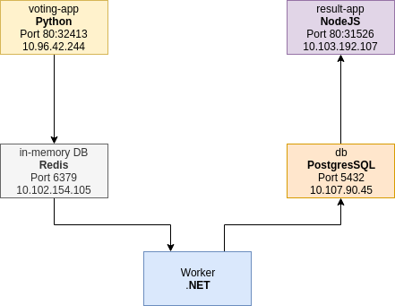

2.5 - Scaling Up
Edit the voting-app-deployment.yaml file and change the value of the replicas field from 1 to 3 :
root@kubemaster:~/app# vi voting-app-deployment.yaml
root@kubemaster:~/app# cat voting-app-deployment.yaml
---
apiVersion: apps/v1
kind: Deployment
metadata:
name: voting-app-deployment
labels:
app: demo-voting-app
spec:
replicas: 3
selector:
matchLabels:
name: voting-app-pod
app: demo-voting-app
template:
metadata:
name: voting-app-pod
labels:
name: voting-app-pod
app: demo-voting-app
spec:
containers:
- name: voting-app
image: dockersamples/examplevotingapp_vote
ports:
- containerPort: 80
Edit the result-app-deployment.yaml file and change the value of the replicas field from 1 to 3 :
root@kubemaster:~/app# vi result-app-deployment.yaml
root@kubemaster:~/app# cat result-app-deployment.yaml
---
apiVersion: apps/v1
kind: Deployment
metadata:
name: result-app-deployment
labels:
app: demo-voting-app
spec:
replicas: 3
selector:
matchLabels:
name: result-app-pod
app: demo-voting-app
template:
metadata:
name: result-app-pod
labels:
name: result-app-pod
app: demo-voting-app
spec:
containers:
- name: result-app
image: dockersamples/examplevotingapp_result
ports:
- containerPort: 80
Apply the changes using the kubectl apply command:
root@kubemaster:~/myapp# kubectl apply -f voting-app-deployment.yaml
Warning: kubectl apply should be used on resource created by either kubectl create --save-config or kubectl apply
deployment.apps/voting-app-deployment configured
root@kubemaster:~/myapp# kubectl apply -f result-app-deployment.yaml
Warning: kubectl apply should be used on resource created by either kubectl create --save-config or kubectl apply
deployment.apps/result-app-deployment configured
Then check the Deployments :
root@kubemaster:~/myapp# kubectl get deployments
NAME READY UP-TO-DATE AVAILABLE AGE
postgres-deployment 1/1 1 1 23h
redis-deployment 1/1 1 1 23h
result-app-deployment 3/3 3 3 23h
voting-app-deployment 3/3 3 3 23h
worker-app-deployment 1/1 1 1 23h
as well as the PODs :
root@kubemaster:~/myapp# kubectl get pods -o wide
NAME READY STATUS RESTARTS AGE IP NODE NOMINATED NODE READINESS GATES
postgres-deployment-5b8bd66778-j99zz 1/1 Running 1 169m 192.168.35.83 kubenode2 <none> <none>
redis-deployment-67d4c466c4-9wzfn 1/1 Running 1 169m 192.168.205.217 kubenode1 <none> <none>
result-app-deployment-b8f9dc967-nzbgd 1/1 Running 1 169m 192.168.205.218 kubenode1 <none> <none>
result-app-deployment-b8f9dc967-r84k6 1/1 Running 0 2m36s 192.168.35.86 kubenode2 <none> <none>
result-app-deployment-b8f9dc967-zbsk2 1/1 Running 0 2m36s 192.168.35.85 kubenode2 <none> <none>
voting-app-deployment-669dccccfb-jpn6h 1/1 Running 1 169m 192.168.35.82 kubenode2 <none> <none>
voting-app-deployment-669dccccfb-ktd7d 1/1 Running 0 2m50s 192.168.35.84 kubenode2 <none> <none>
voting-app-deployment-669dccccfb-x868p 1/1 Running 0 2m50s 192.168.205.219 kubenode1 <none> <none>
worker-app-deployment-559f7749b6-jh86r 1/1 Running 2 169m 192.168.205.216 kubenode1 <none> <none>
In the case of the example in this course, the application now looks like the following diagram:
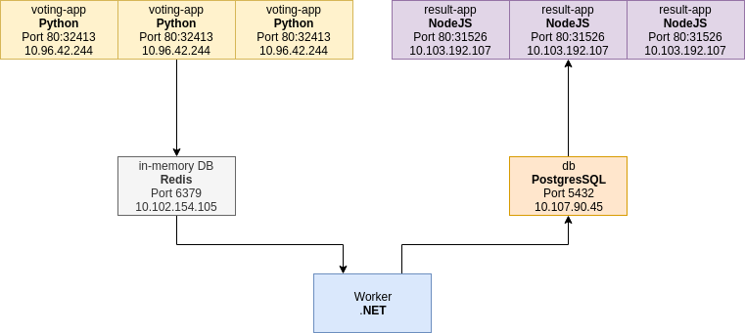
Return to the browser on your host machine and refresh the voting-app page:
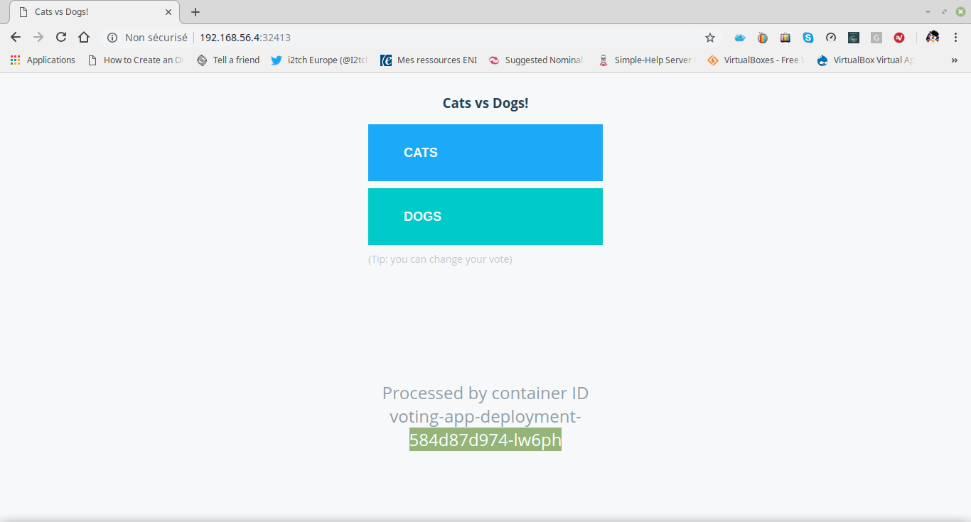
Important: Note the POD that served the page.
Refresh the page again:
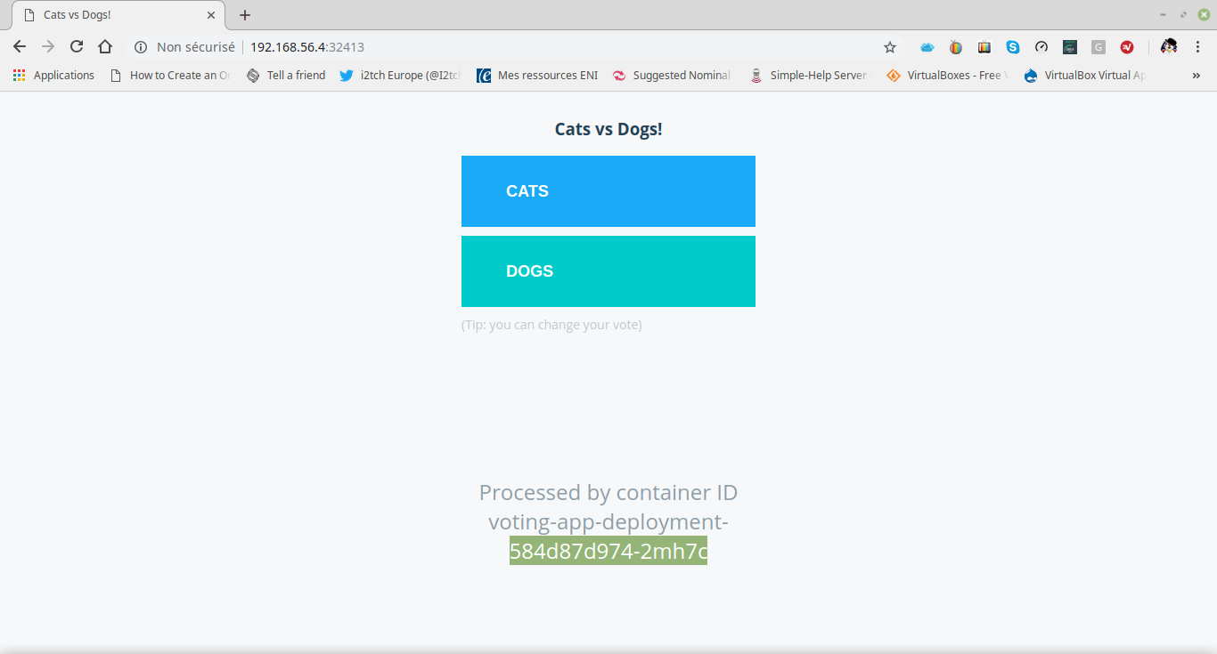
Important: Note that the POD that served the page has changed.
Note that this POD change does not indicate load balancing. You'd have to set up another virtual machine under, say, HAProxy to achieve load balancing.
On the other hand, in the case of an application on GCP, for example, you need to modify the following two files by changing the type field value from NodePort to LoadBalancer and then configure an instance of GCP's native Load Balancer:
root@kubemaster:~/app# vi voting-app-service.yaml
root@kubemaster:~/app# cat voting-app-service.yaml
---
apiVersion: v1
kind: Service
metadata:
name: voting-service
labels:
name: voting-service
app: demo-voting-app
spec:
type: LoadBalancer
ports:
- port: 80
targetPort: 80
selector:
name: voting-app-pod
app: demo-voting-app
Important: This file describes a LoadBalancer Service. Note that the Service exposes port 80 on any POD with the name voting-app-pod.
Finally, create the file result-app-service.yaml :
root@kubemaster:~/app# vi result-app-service.yaml
root@kubemaster:~/app# cat result-app-service.yaml
---
apiVersion: v1
kind: Service
metadata:
name: result-service
labels:
name: result-service
app: demo-voting-app
spec:
type: LoadBalancer
ports:
- port: 80
targetPort: 80
selector:
name: result-app-pod
app: demo-voting-app

Copyright © 2025 Hugh Norris

