Version: 2024.01
Last update:

Cockpit

1.1 - Starting Cockpit
Cockpit is the new Red Hat 9 server management interface. It is installed by default.
Activate and start the cockpit socket:
[root@redhat9 ~]# systemctl start --now cockpit.socket
[root@redhat9 ~]# systemctl status cockpit.socket
● cockpit.socket - Cockpit Web Service Socket
Loaded: loaded (/usr/lib/systemd/system/cockpit.socket; disabled; preset: disabl>
Active: active (listening) since Sat 2024-10-26 15:26:22 CEST; 16s ago
Until: Sat 2024-10-26 15:26:22 CEST; 16s ago
Triggers: ● cockpit.service
Docs: man:cockpit-ws(8)
Listen: [::]:9090 (Stream)
Process: 74750 ExecStartPost=/usr/share/cockpit/motd/update-motd localhost (code>
Process: 74757 ExecStartPost=/bin/ln -snf active.motd /run/cockpit/motd (code=exi>)
Tasks: 0 (limit: 48799)
Memory: 92.0K
CPU: 19ms
CGroup: /system.slice/cockpit.socket
Oct 26 15:26:22 redhat9.ittraining.loc systemd[1]: Starting Cockpit Web Service Socke>
Oct 26 15:26:22 redhat9.ittraining.loc systemd[1]: Listening on Cockpit Web Service S>
[root@redhat9 ~]#
If necessary, add a rule to the firewall so that cockpit can be used:
[root@redhat9 ~]# firewall-cmd --add-service=cockpit --permanent
Warning: ALREADY_ENABLED: cockpit
success
Turn on SELinux's permissive mode:
[root@redhat9 ~]# setenforce permissive
Add trainee to the group wheel :
[root@redhat9 ~]# usermod -aG wheel trainee
[root@redhat9 ~]# groups trainee
trainee : trainee wheel
[root@redhat9 ~]# exit
logout
[trainee@redhat9 ~]$ groups
trainee
[trainee@redhat9 ~]$ newgrp trainee
[trainee@redhat9 ~]$ exit
Reconnect to your Red Hat 9 VM and check that you are now in the wheel group :
[trainee@redhat9 ~]$ groups
trainee wheel

1.2 - Connecting to Cockpit
Open the Debian11_10.0.2.46_VNC connection in the Guacamole interface. Connect as trainee and open the web browser. Enter the address https://10.0.2.101:9090. Click on the Advanced button:
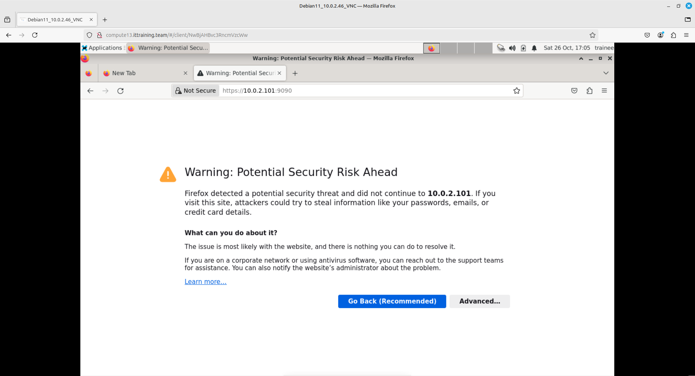
Click on the Accept the Risk and Continue button:
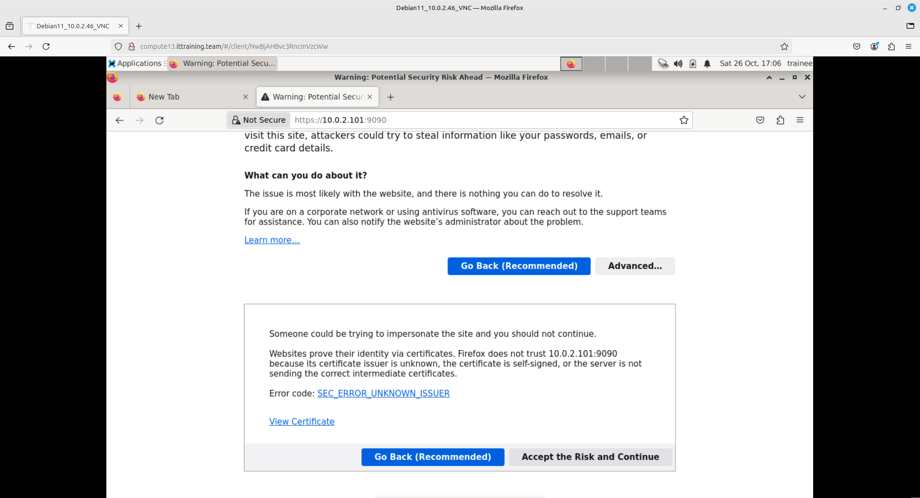
Enter the trainee / trainee login details and click on the Log in button:
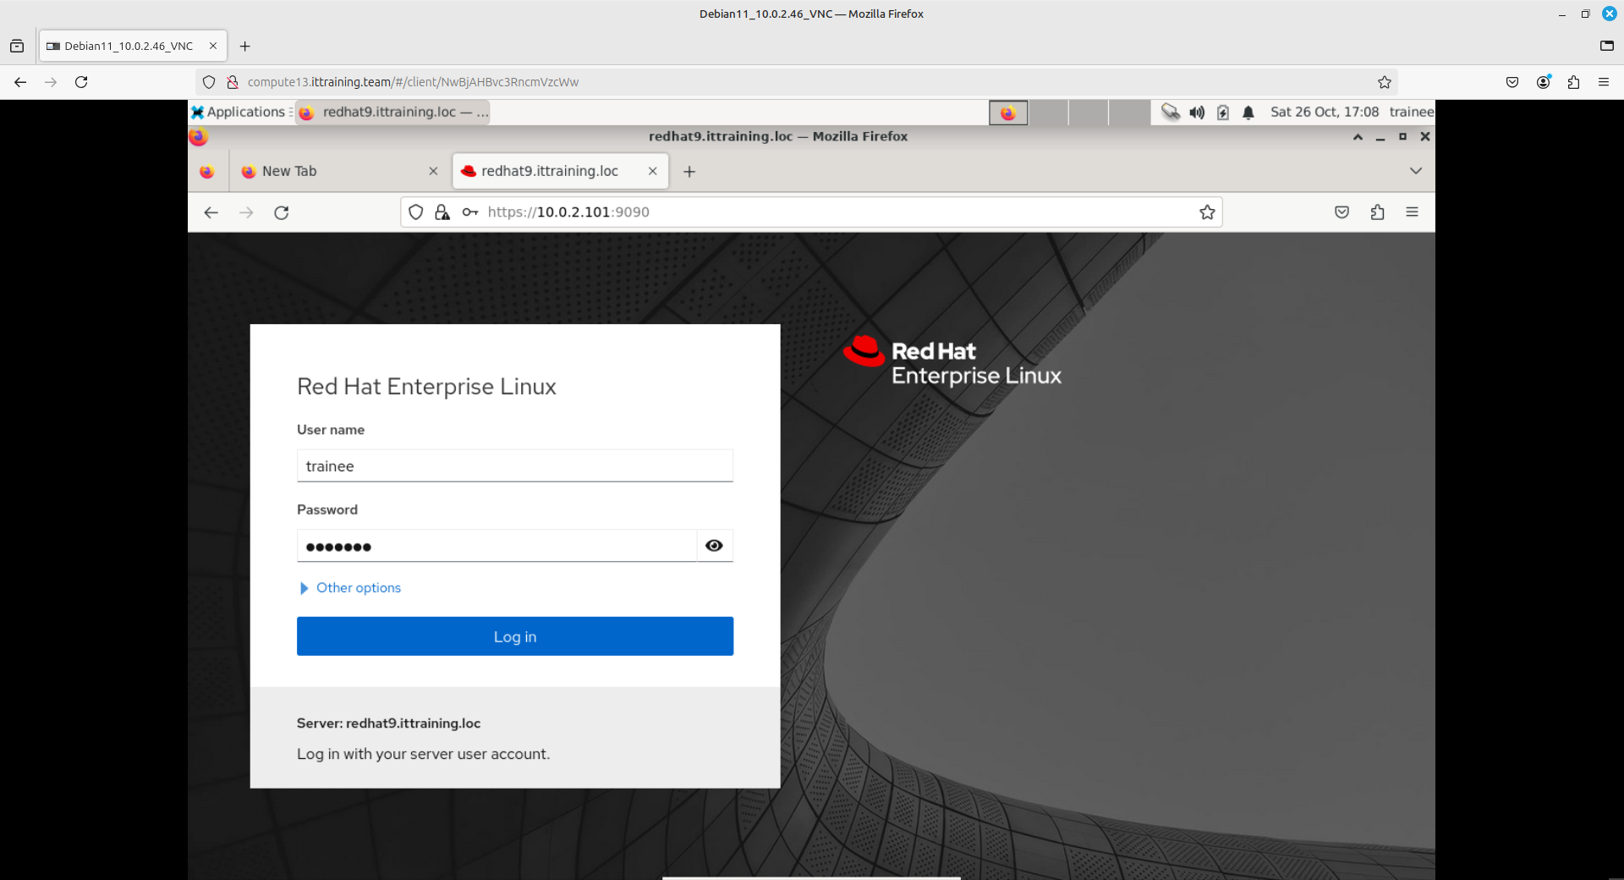
Click on the Turn on administrative access button:
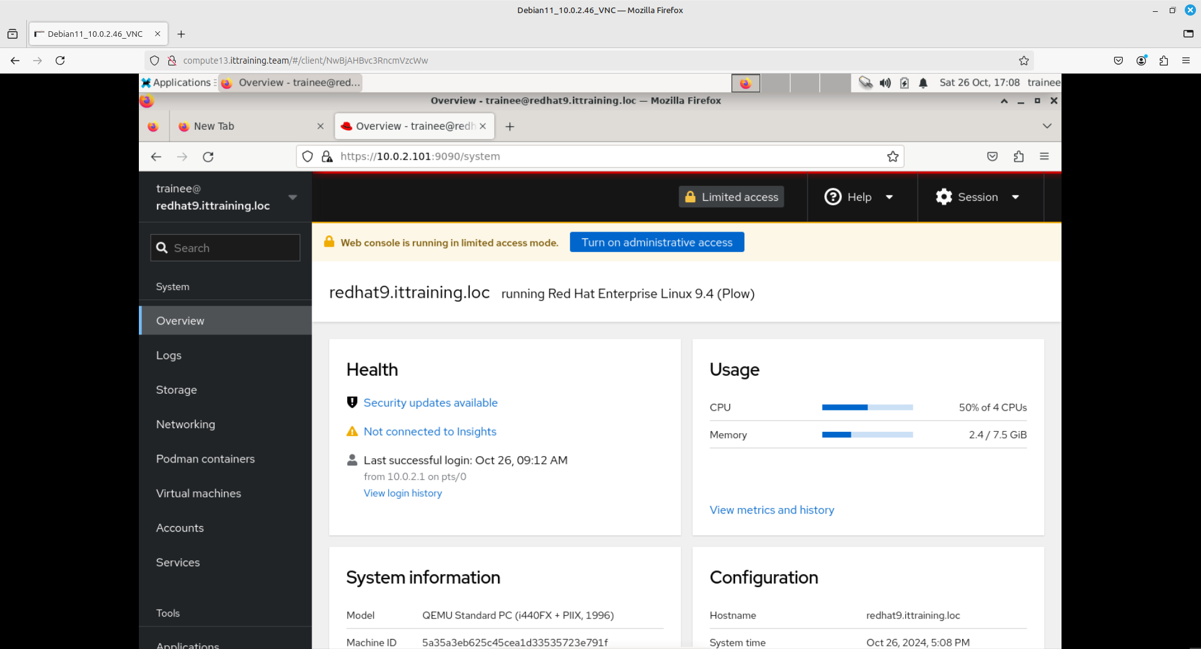
Enter the password trainee and confirm:
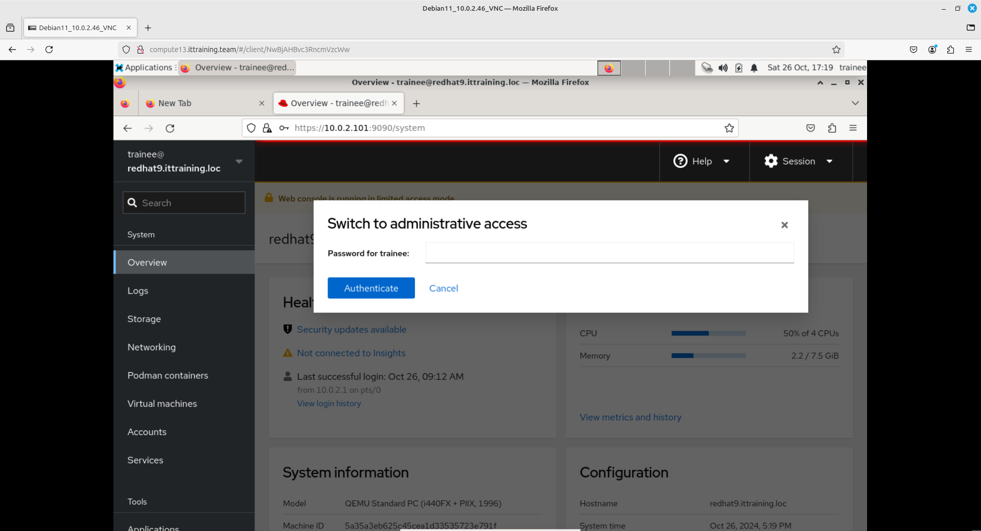

Copyright © 2024 Hugh Norris.

